**School of Public Health Equity and Action**

**(SOPHEA)****2022-23**

**MULTIMORBIDITY AND PHYSICAL ACTIVITY INTERVENTION IN FEMALES IN RURAL ALIGARH**

*A Report on the Community Health Learning* *Experience*

Group 118





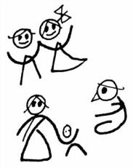

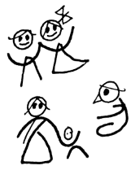

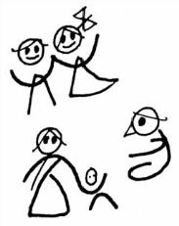

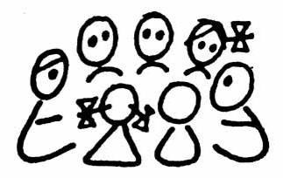





**INDEX/CONTENT**

###### PART A

###### Introduction

###### Why did I join the Fellowship?

###### Learning Objectives

###### Areas of interest

###### Learning modules & Reflections

###### Modules

###### Non Communicable Diseases

###### Social Determinants of Health

###### Comprehensive Primary Care (CPHC) — Ayushman Bharat

###### Communication for Health

###### Balance between work,life & CHLP maintained

###### Mentorship & Reflections

###### Project learning experience

###### Take away from CHLP

PART B

###### Summary

###### Analysis table

###### -Problem

###### -Interventions

###### -Results

###### SWOT Analysis

###### -Strengths

###### -Weakness

###### -Threats/Challenges

###### –Opportunities

###### Benfits of Physical Exercise

###### Physical Exercises demonstrated

**PART A**

**CHLP Learning**

1. Introduction

My name is Asra Saqib and currently I am a postgraduate medical student pursuing my MD in Community Medicine from Jawaharlal Nehru Medical College, Aligarh Muslim University, where I also completed my undergraduate course and internship training. I was exposed to the immense importance of community health from an early age from my teachers and mentors, which strengthened my resolve to enter medical school in 2013 to be of service to the people. Community Medicine quickly became my subject of interest during my undergraduate years, which was intensified during my clinical internship in 2018, by the field visits to the disadvantaged communities and witnessing a hands-on approach by my teachers to inculcate a sense of comprehensive health care attitude in the community members during outreach activities so that they better respond to their health care requirements by being finely tuned to their needs.

1. Why did I join the fellowship?

I found The Community Health Learning Programme (CHLP) by the Society for Community Health Awareness Research and Action (SOCHARA) a unique and exciting prospect for a young professional such as myself due to the individual - centric and hands on approach the programme provides to its participants in all matters pertaining to public health. This was the first time that this programme was being conducted online, thus providing me with an ease of access as well. I also joined this programme to broaden my horizons beyond the context of medical jargon and definitions, to include more encompassing sociological point of views. This was also an opportunity for me to gain valuable insights from the programme attendees through their shared experiences working in the field of community health.

1. What were my learning objectives and were they met?

Community Health enables people to collectively exercise their own health’s responsibility and demand it as their right. It involves increasing the autonomy and providing power to the individual, family and community to take up their own health in their own hands by providing the means, opportunities, the knowledge and the supportive structures that make health possible. SOCHARA helps health activists who focus not only on medical health but also give equal importance to social change. It enables and empowers people rather than just provide curative care. My learning objectives from this course were to develop an appreciation of sociological variables which will strengthen my knowledge, attitude and skills when dealing with problems that require a comprehensive approach in the future and boost my capabilities as a public health specialist by increasing my awareness and improving my inclusivity of all things related to Community Health. I feel like I have achieved 85-90% of my objectives by joining this comprehensive course and it has helped me define the word “Community Health” very well, with respect to the field area I work in.

**My areas of interest are**:

* + - Non Communicable Diseases
    - Social Determinants of Health
    - Comprehensive Primary Care (CPHC) — Ayushman Bharat
    - Communication for Health

1. Learning from modules and how I applied the learning in my work.

Reflections on use of the LMS, videos and participation in live online sessions

The modules have been extremely informative and the body of knowledge vast and thoroughly researched. I have been studying a lot of things in my postgraduate course like CPHC, Universal Health Coverage, Social Determinants of Health, etc, but never in such detail. These modules provided a proper historical background of how everything came to be, thus providing a good context to what I am learning in our course, making me think of these topics in a new light and with fresh eyes. As the modules progressed, I gleaned more practical knowledge on how to apply these concepts in my day to day work while interacting with the patients, in the OPD as well as in the field settings, especially the latter, where Community Health becomes of paramount importance. The live sessions and discussions were extremely informative and thought provoking, and it was a treat to listen to the stalwarts of public health share their ideas, stories and input.

The modules that interested me most were:

* **Non Communicable Diseases** —

**Risk Factors** are defined as “ an attribute or exposure that’s significantly associated with the development of disease” or “ a determinant that can be modified by intervention, thereby reducing the possibility of occurrence of disease or other specified outcomes.” Usually, most of the Non Communicable Diseases are the result of FOUR particular behaviours-

1. Tobacco use
2. Physical Inactivity
3. Unhealthy diet
4. Harmful use of Alcohol

This leads to FOUR key metabolic/physiological changes:

1. Raised blood pressure
2. Overweight/obesity
3. Raised blood glucose
4. Raised cholesterol

One of the important difference between Communicable and Non Communicable diseases is that the Causative agent or risk factor is easily identifiable in case of Communicable diseases, but obscure and multifactorial in case of Non Communicable diseases.

The four risk factors given above are MODIFIABLE, which means they can be changed for the better in the person by making some lifestyle changes. Tobacco accounts for 7.2 million deaths a year, excess salt intake is attributed to 4.1 million deaths a year, 1.6 million deaths can be attributed to physical inactivity and half of 3.3 million deaths due to alcohol are intake are due to development of NCDs.

Metabolic risk factors: The leading metabolic risk factor globally is elevated blood pressure, followed by overweight or obesity and raised blood glucose.

Control of NCDs — control and reduction of risk factors. Monitoring trends of NCDs is important for making policies and guiding their priorities.

Lessen the impact of NCDs — collaborative effort by all spheres of the society — health, finance, education, transport, etc. Management of NCDs is also very important, which includes screening and treating the diseases and providing palliative care. That is why, primary health care and health insurance coverage is important to ensure universal health coverage.

Target — achieve SDG goal of reduction of premature deaths from NCDs by one-thirds by 2030.

Primordial prevention plays a very important role in the reduction of NCDs. — elimination of risk factors even before their occurrence in the environment.

The underlying drivers of NCD prevalence are social determinants of health, globalisation, urbanisation and population ageing, which lie at the bottom of the pyramid, and interventions against them are more cost-effective, cover large populations at a time and multisectoral in nature.

TOBACCO — It is a modifiable risk factor. In India, 48% chew tobacco, 38% consume bidis and 14% consume cigarettes.

Factors influencing tobacco use:

1. Pleasure
2. Peer pressure
3. Stimulant and a depressant
4. Curiosity
5. Freedom of expression

It is also completely legal to grow, sell, import and export tobacco in all forms, which aids in easy exposure. It can lead to addiction, passive smoking, cancers, environmental degradation, raised blood pressure, is an immense drain on the economic resources of the family.

Framework Convention of Tobacco Control (FCTC) — First measure to address global tobacco laws and consumption.

CANCER — One of the leading causes of death in the world, with approx. 70% concentrated in low and middle income countries. Only 1 in 3 countries report quality data on cancer. Between 30-50% of the cancers is preventable by a healthy lifestyle, and others can be screened for, diagnosed early and treated rapidly and accurately. In late stage cancer, the sufferings of the patients should be reduced by good palliative care.

National Cancer Control Programmes — to avoid and reduce exposure to risk factors involved in the causation of cancer, and early detection and treatment of those patients who present with the disease.

**My implementation -** I have a keen interest in Non Communicable Diseases; in fact my thesis topic is very closely related to the incorporation of non communicable diseases in addition to communicable diseases. My focus is on the burden of multiple morbidities on a single individual in the community, with a special attention directed to the socioeconomic factors associated with such morbidities in the context of the community they live in. I would like to hone my skills to better seek out such cases in the community and find out the underlying causes, including healthcare utilisation by the patients. I would like to improve my understanding, training and learning in this field to better treat such patients.

**Case Study -** On a routine field visit, Mr X, 50 year male, was found to have multimorbidity, with dual diabetes and hypertension since the past 5 years. He had visited a private practitioner only once for his ailment and was taking his medications on and off, as he felt like it or when the symptoms worsened. On further inquiry, he revealed that the drugs that he was prescribed were expensive and he could not afford to buy them every month, and that he had heard that there were no drugs available at the Rural Health Training Centre (RHTC).

**Implementation -** A thorough and detailed socioeconomic history the patient was taken in addition to disease history and examination. The patient, initially skeptical of health workers from the RHTC, warmed up after being given some time and attention to his problems. His misconception about non-availability of drugs at the RHTC was quelled and the harmful effects of not taking medication was explained to him. He promised to go to RHTC to stay complaint on his drugs, and also added that he would tell his friends in the village that it was not right to skip their prescribed medicines and to take them from the RHTC.

**Current Situation -** Follow up on the patient revealed that he did go to the RHTC and was taking his medicines fairly regularly now, in addition to walking for 15-20 minutes every evening.

* **Social Determinants of Health**

Social determinants of health (SDH) can be described as conditions in which people follow their life cycle and the wider set of forces and systems shaping their day to day life. In that context, “Health Inequities” are health differences that are socially produced, systematic in their distribution across the population, and unfair. These inequities impact the functional capacities of individuals and impinge on their freedom, dignity and rights, which then impacts their health. Health Equity, therefore, forms an important component of social determinants of health.

CORE VALUES — The primary responsibility for protecting health equity rests with the government. Empowerment is another, where, the foci of decision making shifts from the state to the people. Empowerment enables those who are at a disadvantage to exercise the greatest possible control over their rights. Therefore, action should be taken to redistribute power to the disadvantaged as well.

**Framework for action on SDH, 2010** was to conceptualise the emerging knowledge on SDH and was based on the core values of “Health for All.” It was formed by the Commission on Social Determinants of Health (CSDH) IN 2008. It identified three critical areas where improvement was needed:

1. Improve daily living conditions
2. Tackle the inequitable distribution of power, money and resources
3. Measure and understand the problem and assess the impact of action.

The **objectives** of a comprehensive SDH Framework includes:

1)Identify the social determinants of Health

2)Show how they relate to each other

3)Clarify the mechanisms by which health inequities are generated

4) Address which SDH are the most important

5)Map specific levels of interventions

**SOCIAL VACCINE** — It can be defined as “actions that address social determinants and social inequities in the society, which act as a precursor to the public health problem being addressed.” It is a process of social and political mobilisation which leads to increased accountability by the governments and is applied to populations rather than individuals. It acts in the same way a vaccine does, I.e. as the preventative solution. It is aimed at structural determinants. A resistance against unhealthy policies spreads through the community like immunity, thus providing the impetus for change. Eg. Protesting against raised prices on crops by farmers and unequal land distribution.

“**Cultural Safety**” has the key notion of ‘power.’ It includes delivering quality care through changes in power dynamics and patient rights, and recognising that barriers to access and equity are due to inherent power imbalances between the provider and the patient. It requires a critique of already existing power structures, and health equity is the endpoint. It also addresses structural determinants of health.

**My Implementation**- As a researcher, some **culturally safe approaches** that I can take while talking to respondents of my study can be:

1. Listening and reflecting critically
2. Following cultural practices that have been stipulated for outsiders
3. Sharing in their lives and trying to understand their culture as closely as possible
4. Sharing and discussing results with communities
5. Being empathetic towards their problems
6. Practicing good body language
7. Consciously avoiding putting myself in a position of power
8. Engaging key community informants

**Case Study** **1** - On visiting the field, it was seen that many of the villagers who were on medication for their chronic illnesses were not taking their medication regularly. On inquiry, it was found that a lot of them, especially in the lower socioeconomic strata, did not have faith that the health care provider will talk to them or take their issues seriously.

**Implementation** - A detailed discussion with the aggrieved persons was conducted by listening and reflecting on their problems critically, being empathetic towards the issues they are facing, practicing good body language and trying to understand their culture. A conscious choice to sit equally at level with the persons concerned was taken so as to avoid putting myself in a position of power. They were assured of proper treatment upon visitation to the health facilities with proper addressing of their issues.

**Current Situation** - A number of those people who were hesitant to come with their problem were seen in the OPDs of the health facility, taking their treatment. After talking to them, they reported they had a better experience than expected.

* **Comprehensive Primary Care (CPHC) — Ayushman Bharat**

Primary Health Care is a an important context that needs a wider audience. The Alma Ata declaration in 1978 focussed on Primary Health care as a path to approach “Health for All” by the year 2000. The declaration reaffirmed health as a basic human right which required intersectoral coordination, where health inequalities are unacceptable, and the governments have a responsibility to ensure this provision. Primary health care was thus a practical approach to ensure universally accessible health care which was acceptable to the families and was implemented with their participation and coordination to promote health and prevent diseases. The **aim of CPHC** is to provide a seamless continuum of care that ensures the principles of equity, quality, universality and no financial hardship.

The **principles** of Primary Health care are:

1) Health prevention, promotion and rehabilitation — the care needs to be comprehensive, which also includes education, food and nutrition

2) Equity — must be accessible to all

3) Appropriate technology — technology used should be acceptable to all in the community where primary health care is being applied, and should use local resources

4) Community participation — self reliance and social awareness are important, and communities assuming responsibility for their own health is required

5) Intersectoral coordination — it includes participation from all sectors, like education, agriculture, food and nutrition, etc.

6) Relies on local and referral system — community provides the managerial role, and community health workers are the first level of contact between individuals of a community and its health care system.

**AYUSHMAN BHARAT PROGRAMME** — It was created to address the rising challenges of underutilisation of primary care services, increasing burden on tertiary care and the growing burden of non-communicable diseases. It has two components:

1. Health and wellness centres (HWCs) - to deliver **comprehensive primary health care (CPHC)**
2. Pradhan Mantri Jan Arogya Yojana (PM-JAY) - insurance and improving access to tertiary care

ASHA and MPW will undertake home visits to assess risk, improve care seeking behaviour, screening, etc. The HWCs will be open for a minimum of 6 hours and will also conduct outreach and house visits. There will also be referral support. A new cadre of workforce, the **Community Health Officer**, holding a qualification of BSc. Nursing or Community Health, or an AYUSH practitioner, was formed to operate the HWCs. The rationale behind this was to improve the outreach activities, improve community participation, offer an expanded range of services closer to the community and improve public health activities. Health Promotion is a key feature under this programme, which also includes yoga sessions conducted weekly at the centres.

This programme can be beneficial in the following ways:

1. Includes preventive and promotive healthcare in addition to curative care.
2. Telemedicine introduced.
3. Two-way referral system.
4. Trained staff.
5. New Cadre of workforce- Community Health Officer
6. States have been given freedom to adapt according to their needs.
7. Addressed mental and geriatric health and introduced CA screening.
8. Digitalization by way of laptops/ tablets.
9. Advantage of an already existing system of SHCs and PHCs.

**Implementation** - A Health and Wellness Centre is present in Aligarh, in Panjipura village. It was a sub-health centre which was converted to a HWC and provides a two-way referral system option to the beneficiaries of the village, linking it to Jawaharlal Nehru Medical College as well. It also has ample space in the front of the building to conduct yoga sessions.

**Current situation** - The village folk were made aware of the facilities provided at the HWC and may showed an especially keen interest in the yoga sessions. Many of them turned up for the weekly yoga session conducted and had a good experience with the services and exercises. The Community Health Officer also established a good rapport with the villagers.

* **Communication for Health** - One of the most important challenges for communication regarding health is the reach that is required to the community members and new partners. To bring about a positive change in the health of people, knowledge. Attitudes and practices need to be targeted and this can be done effectively through good communication practices. This process includes;
* IEC - Information Education Communication,
* Health education
* Information campaign
* Health promotion and advocacy for health

Communication is explained as a process of transferring message from the sender to the receiver through a certain channel.The process of putting thought in to a symbol for sending is called “encoding” and the seat of such symbols to be sent is called a “message.” The process of assigning meaning to the symbols by the receiver is called “decoding.” The receiver may then provide feedback as a part of the receivers response. There can be unplanned distortion during the whole communication process, which is known as “noise.” Therefore, proper planning of a communication process is essential.

Communication in the context of health is important not only for imparting knowledge to the community members but also for changing the attitude, practices and habits of people towards a more healthy life. This will thus lead to a change in the environment and a prevention and control of ill health in the community. Many factors influence change in the attitude on getting information, like value and culture systems. Other factors like non availability of facilities may hamper new practice behaviour.

There are two main channels of communication: **Mass media and interpersonal communication**.

Interpersonal communication involves face-to-face communication with individuals and groups. These could be:

1. Role plays
2. Street theatre
3. Folk songs/folk media
4. Exhibition
5. Puppet shows
6. Village fairs, etc.

The **principles** of communication include:

1. Communication should be a two-way process
2. Language should be simple and in the local vernacular; jargon free with colloquial expressions
3. Local events, positive beliefs and lives of well-known people should be used in communication. Local folk stories should be adapted.
4. Communicators should listen to the community members
5. It must be focussed
6. It should be audience oriented and not teacher oriented and should be interactive
7. Role plays and real life situations should be utilised, and health or community workers who have personally experienced the or done the work should address the crowd

To evolve an effective IEC programme, the main steps are as follows:

1. Learn about the existing knowledge, behaviour and attitudes of the community members
2. Find out the sources of information that the community members utilise to get their health information from
3. Review all the communication channels and decide which route would be the best to impart knowledge
4. Identify whom in the community do you want to reach with what message
5. Define the ideas you are promoting
6. Design messages on the knowledge pertaining to the specific health programmes

**Implementation**: On the event of World Breastfeeding Week, we at Rural Health Training Centre (RHTC) Jawan conducted a rally to impart information on the importance of breastfeeding to the nearby village members. We stressed on the need for cultivating good breast-feeding practices, the benefits of breastfeeding and why exclusive breastfeeding should be done for six months. We demonstrated the correct position for latching and attachment during feeding to newly lasting mothers, and addressed any concerns they had regarding positioning and milk let down. We also talked about how the support from family members, especially the husband and mother in law, were imperative in ensuring adequate support and comfort to the mother, and not just relative the job to her alone. We counselled the beneficiaries on initiating breastfeeding as soon as possible after birth, and the immense importance of giving colostrum to the babies and avoiding prelacteals.

**Current Situation**: Many pregnant and new mothers, after listening to the talk, came to us with their grievances regarding breastfeeding, like having engorged breasts and mastitis. We demonstrated the correct way to express the remaining milk into a katori for feeding the child and to relieve the painful engorgement and counselled them on the importance of feeding the child from both the breasts and emptying them completely. Some of them also came to us to learn the proper positioning and latching to see whether they were doing it correctly and the baby was getting adequate milk or not.

5.How was a balance between work, life and the CHLP maintained?

During the start of the course there were still some restrictions due to the pandemic and our daily workalike was quite different from what it is now. My classes were more relaxed and thus were getting more time to do the work in these courses. But when all restrictions ended, we swung in full force at college, and as I was ending my second year of M.D. and entering the third, I had a lot of thesis work to do, including going on filed visits daily to collect my data for hours on end. In the midst of this my sister had to undergo surgery and I had to be there for her, and just when I returned and things were getting back to normal, I suffered a slipped disc and stenosis. This couldn’t have come at a worst time as I had my thesis submission just round the corner, plus aIl the remaining CHLP course work that I had left to do. felt I would not be able to manage the CHLP course but with the help of SOCHARA team and my mentor I got the confidence to complete the course and started reviewing all the course material for CHLP, and I especially revisited all the courses which were of great interest to me.

1. Mentorship process and reflections

My mentor is **Dr. Pruthvish S**- Public Health Expert, Former HOD, Department of IC Community Medicine, M S Ramaiah Medical College, Bangalore. He served in St. Johns Medical College, Bangalore, ACTIONAID - India, and was a consultant for UNICEF for MCH activities at India Country Office, New Delhi; WHO – International Expert Consultant on Health Care Waste Management in Banda Aceh, Indonesia (Post Tsunami) with WHO SEARO ; Papua Guinea with WHO WPRO; and worked with WASTE, Netherlands in India and Sri Lanka (Post Tsunami). He was also the State Neonatal and Child Health Consultant, Karnataka, UNICEF. Currently he serves as Consultant –ICMR, NCDIR, Bengaluru. He has also authored chapters in Textbook of Preventive Cardiology, Community Dentistry and training manuals of IGNOU on Health Care Waste. He has more than fifty scientific publications in national and international journals. His areas of interest are NCDs, Cancer, Stroke, DM, CHD, Health care Waste Management and Community Based Rehabilitation of Persons with Disability.

I was very fortunate to have such a learned and experienced person as Dr. Pruthvish as my mentor and was very happy that my topics of interest and in fact my thesis topic itself aligned with his areas of interest. I got a lot to learn during this course from his knowledge and his live sessions on NCDs especially were very informative and and helpful to me in shaping my project for SOCHARA. I was immensely encouraged to finish my course and hone a keener interest in my work because of him.

Special thanks to Karthik as he has always been unwavering in his support to all the CHLP fellows, with the patience of a saint. He regularly messaged and followed up with me whenever I was lacking and falling behind and patiently listened to my problems, and gave me ample time to get my affairs in order. He encouraged me to go the last leg and finish the course, when I felt like giving up and thought it too much for me.

I especially enjoyed Janelle’s sessions as they were filled with all sorts of interesting information and very insightful regarding what we had set out to learn. I also found Mrs. Thelma’s sessions to be very enlightening, and the discussions were absolutely one of the best I have ever had a chance to witness and be a part of.

1. Project learning experience

* The project is based on the concept of Multimorbidity, that is two or more chronic diseases occurring simultaneously in an individual
* Majority of the chronic diseases are non communicable and can be modified or prevented by behavioural and lifestyle choices
* Also, females have shown to have a higher propensity towards Multimorbidity, likely due to their comparatively sedentary lifestyles.
* Therefore, I decided to focus on the physical activity aspect, by expelling its benefits and recommend a set of culturally relevant activities that can be practiced easily from the comforts of the home of these women.
* I chose to do this project as Non Communicable diseases as a topic has been very interesting for me from the get go. I even based my thesis topic on the same.
* Multimorbidity is especially important and relevant in today’s context because India has already undergone an epidemiological transition and we know so many people around us with multiple NCDs.
* The threat is very real and now it has managed to percolate into the rural areas as well.
* I visited multiple villages to gauge and assess the situation and find out the prevalence of Multimorbidity in the residents, particularly women.
* I had wonderful field workers with me who helped break the ice and thus establish a good rapport with them
* My experience with this project was that never to take anything at face value, and always be a good listener.
* Through this project I learned to look at multiple dimensions and determinants of an individuals health, and what cultural and social behaviours shapes their habits and lifestyle.
* It allowed me to look at multiple factors when searching for the how’s and the why’s of a certain disease occurring in a particular individual.
* Recommending exercises to women was one of the most fun and interesting parts of the project.

1. Take away from CHLP and Looking Ahead -Where do I go from here?

This CHLP course from SOCHARA was an eye opener in many ways than one. I learned for the first time that even one, one and a half hour long lectures could be so interesting and fun and able to keep your attention for the whole duration of the session. The discussions between fellows truly encouraged me to think in ways that I had previously not thought of, and it was an absolute delight listening to the experiences of people from all walks of life. The modules were absolutely information rich, and I especially loved the examples, the case studies and the anecdotes peppered in between them.

Some of the teachings were new to me and it was a sobering experiences to read and listen about the plight of so many disadvantaged communities and people which should have been nationwide news but was unfortunately only a snippet in some column.

CHLP- SOCHARA has taught me new and different kinds knowledge, attitudes and skills that are required for community based public health actions which require an alternative method of learning. It calls for great experimental and group/ community based self-directed learning and gaining knowledge and information through study-reflection-action cycles.

Looking ahead, I would like to take this same zeal for knowledge that I imbibed from everyone here at CHLP to my future endeavours. CHLP has moulded my critical thinking skills to not only consider the disease and the pathology, but also the social, cultural behaviour determinants behind it. It has increased my appreciation for discussion sessions, and how having an open, honest and transparent dialogue with colleagues helps put your point across succinctly and clearly, and how much value that adds to the process. It has also increased my interest towards the direction of community health, and I definitely will do some projects or field work related to this topic in the future.

**PART B**

**MULTIMORBIDITY AND PHYSICAL ACTIVITY INTERVENTION IN FEMALES IN RURAL ALIGARH**

**Summary:**

Female population make up almost half of the population in rural Aligarh villages, and it was found that more females than males suffered from Multimorbidity, defined as the presence of two or more chronic diseases in an individual.

While focus on Non Communicable Diseases on their own is given the utmost importance, a complex of diseases occurring together are often looked at fragmentally, and thus treated separately. More often than not, most of these chronic diseases have behaviour and lifestyle factors to blame, including physical inactivity, defined as less than 150 minutes of moderate intensity physical activity in a week.

It was seen that women were not partaking in any physical activity other than their housework, contrary to their male counterparts, who had farming and labouring as their occupation. A discussion with these women brought forth many reasons for not partaking in physical exercise.

The aim of this project is to alleviate stigma surrounding physical exercise and thus empower women to take matters of their health in to their own hand by incorporating physical exercise into their daily routines in the safety and convenience of their own homes.

**Analysis Table:**





**SWOT ANALYSIS:**



**Benefits of Physical exercise explained:**

* Managing weight and reducing it.
* Reducing health risk by being a protective factor against many NCDs
* Helps in controlling the symptoms of various diseases, for eg. Helps in controlling and stabilising blood glucose in diabetics
* Builds strength in muscles and thus protects against arthritis and reduces joint pain
* Improves the mood and increases energy, thus the person stays active throughout the day
* Boosts mental health and helps make better decisions as one stays alert and focused
* Improves body image and confidence and provides indolence to the one doing it
* Strengthens mobility and flexibility
* Reduces stress and thus helps in controlling blood pressure

**Physical Exercises Demonstrated:**

* Brisk walking in the verandah for 10 minutes at a stretch, totalling up to half an hour if possible.
* Warming up by stretching arms above the head, then marching on the spot for 10 repetitions.
* Twist: Raise your arms and keep them parallel to the ground, in a “T” pose. Slowly, twist your torso left to right, keeping your feet shoulder distance apart and firmly on the ground.
* Heel to toe: Take support of the wall initially and swing from heel to the ball of your foot. Repeat 10 times, and as balance is regained, do the exercise without wall support.
* Wall press: Stand facing the wall with the back straight. Place the palms flat against the wall, elbows flexing slightly and feet touching the wall. Push away from the wall and come back. Start slow and build repetitions over a few days. Repeat 5 times.
* Hamstring curl: Take the support of the back of the chair and slowly bend the leg at the knee behind you, keeping your thighs at 90 degrees to the ground. Bring your lower leg as far back as it can go, and then release and bring it to the ground. Repeat this 10 times on both the legs.
* Sitting to standing: Start by sitting on a chair or stool high enough that doesn’t require hands to rise, and have another chair in front for support. Stand and sit repeatedly and repeat 10 times. If its too challenging, place a cushion or pillow on the chair/stool.
* T-Rows: Sit upright in a chair and hold near the ends of a dupatta in your hands. Open your arms horizontally to stretch the dupatta, the centre of which should touch the chest. Bring the arms back and repeat it 10 times.
* Bridge: Lie on your back on the bed with your knees bent and feet flat on the mattress. Raise your hips and hold for three seconds at the top, then lower them. Repeat 10 times.
* The women were explained the importance of staying consistence and not giving up after a few days to see good results.
* They were asked to pick the exercises they liked the most and do those first.
* They were encouraged to gather their friends and do the exercises together to make it a fun experience.

GALLERY:

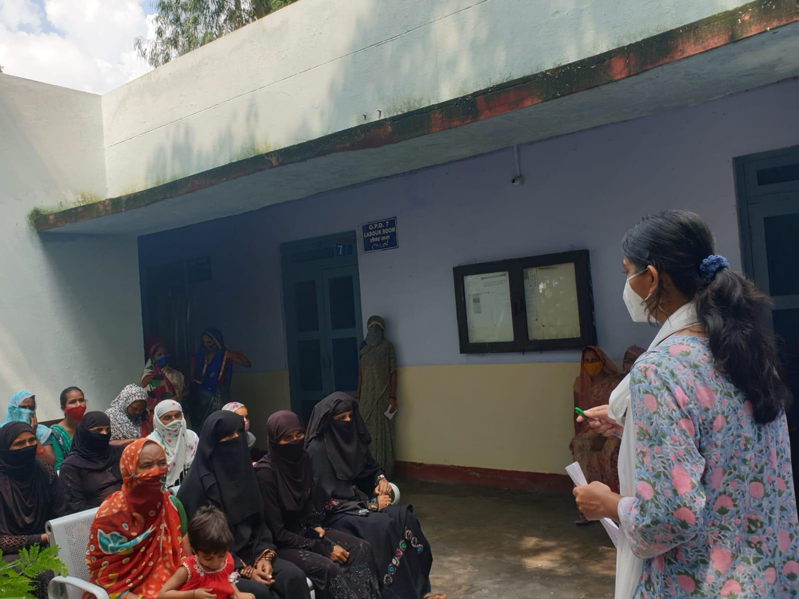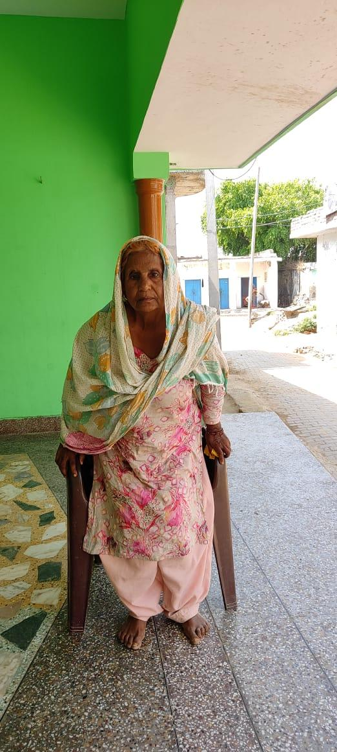

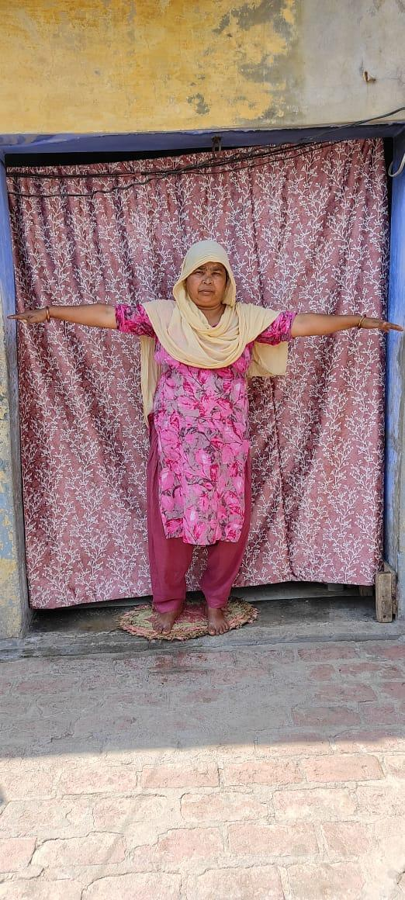



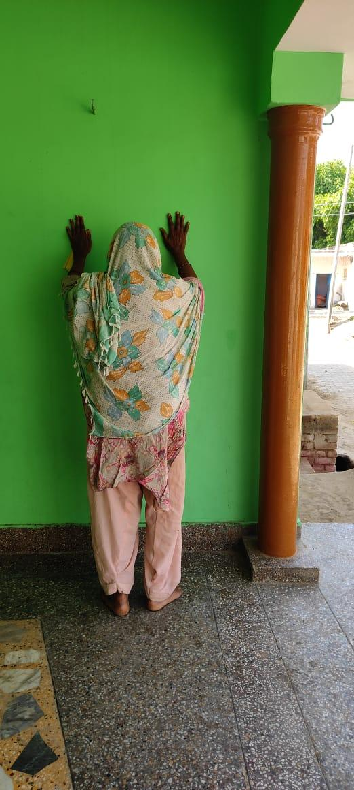

**THANK YOU**