***Understanding the barriers experienced by the people of an urban slum in Bangalore to access the primary diabetes and hypertension care facilitated by the Institute of Public Health (IPH)***

***Name: Anusha Purushotham***

***IPH Supervisors: Dr. Mrunalini Gowda, Dr. Narayanan Devadasan, Dr. Thriveni BS***

***SOCHARA Supervisors: Dr. Rahul ASGR and Mr. Sabu KU***

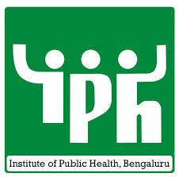

***Table of Contents***

Study details…………………………………………………………………………………………………………………… 1

Background…………………………………………………………………………………………………………………….. 2 – 8

Aim and Objectives……………………………………………………………………………………………………...... 9

Methods………………………………………………………………………………………………………………………….. 10 – 11

Ethical Considerations……………………………………………………………………………………………………… 12 - 14

Results……………………………………………………………………………………………………………………………… 15 – 29

Discussion………………………………………………………………………………………………………………………… 30 - 33

Conclusions……………………………………………………………………………………………………………………… 34

Acknowledgments…………………………………………………………………………………………………………… 35

References……………………………………………………………………………………………………………………….. 36 - 37

APPENDIX 1: Topic Guide for in-depth interviews…………………………………………………………….. 38 - 40

APPENDIX 2: Participant Information Sheet……………………………………………………………………… 41 - 42

APPENDIX 3: Participant Consent Form…………………………………………………………………………….. 43 - 44

APPENDIX 4: Snapshots from the field..…………………………………………………………………………….. 44 - 47

**Study Details**

**Title:**

Understanding the barriers experienced by the people of an urban slum in Bangalore to access the primary diabetes and hypertension care facilitated by the Institute of Public Health (IPH)

**Primary Investigator:**

Anusha Purushotham

**Supervisors:**

Dr. Mrunalini Gowda (IPH), Dr. Rahul ASGR (SOCHARA), Dr. Narayanan Devadasan (IPH), Dr. Thriveni BS (IPH) and Mr. Sabu KU (SOCHARA)

**Name of the Field:**

KG Halli, Bangalore, India

**Duration:**

August 2014 – October 2014

**Affiliations:**

Research report prepared as part of the Community Health Learning Program (CHLP) at SOCHARA (Society for Community Health Awareness, Research and Action), Bangalore, India in collaboration with the Institute of Public Health (IPH), Bangalore, India.

**Funding Details and Budget:**

The researcher was funded through the monthly stipend received in the Community Health Learning Program (CHLP), SOCHARA. All travel costs to the field were covered using these funds.

**Ethics Statement:**

Research proposal was accepted and approved by the SOCHARA Institutional Scientific and Ethics Committee in August 2014.

**Background**

The world is facing a recent epidemiological shift from communicable diseases to chronic non-communicable diseases (NCDs), particularly diabetes and hypertension.In 2008, 36 million out of the 57 million deaths (53%) that occurred across the globe were caused due to NCDs and 80% of the NCD deaths occurred in low and middle income countries (1). Out of the worldwide total of 970 million people with hypertension and 382 million people suffering from diabetes, approximately 640 million hypertensive patients (65.98%) and 305.6 million diabetic patients (80%) live in developing nations (2,3). Therefore, this epidemiological trend is of particular interest in developing nations, especially India, where the disease burden is consistently rising. The prevalence of hypertension in urban India is 25% and rural India is 10-15% (4). With 65.1 million diabetics (prevalence 7.1%), India has the second highest number of people with diabetes in the world (2). In urban south India prevalence of diabetes has risen from 5% in 1984 to 13.9% in 2000 (5).

This rise in the burden of chronic diseases has been complicated by another phenomenon, urbanization. The rate of urbanization in India is proceeding at a very rapid pace with a quarter of the urban population living in slum areas (6). The urban poor experience a very complex set of socio-economic, cultural, and political barriers that lead to inequity in health care access (7, 8). Among all these reasons, even in the general population, affordability is the second most common reason (first reason being people considering the ailment not serious enough) for not seeking health care in India (9) and recent studies in the Indian context have revealed that cost of care alone could be a driving factor to forego care altogether among the poor (10). It is the second most frequently reported reason (after long waiting lines) that the urban slum dwellers in India perceive as a barrier to health services (11).

Kadugodanahalli (KG Halli) is an urban neighbourhood classified as one of the 198 administrative units in the city of Bangalore, the capital of the South Indian state of Karnataka. KG Halli has an area of 0.7 square kilometers and a population of over 44,500 (12). It is a lower middle-class income area with over 75% of the population earning less than $2 a day (INR 110) (8). A slum is generally an area where the urban poor reside, typically characterized by poor living and sanitary conditions. In KG Halli, there are presently two registered slums and one former slum, which was razed down in 2011 and replaced by a corporation quarters with better housing facilities for the slum dwellers.

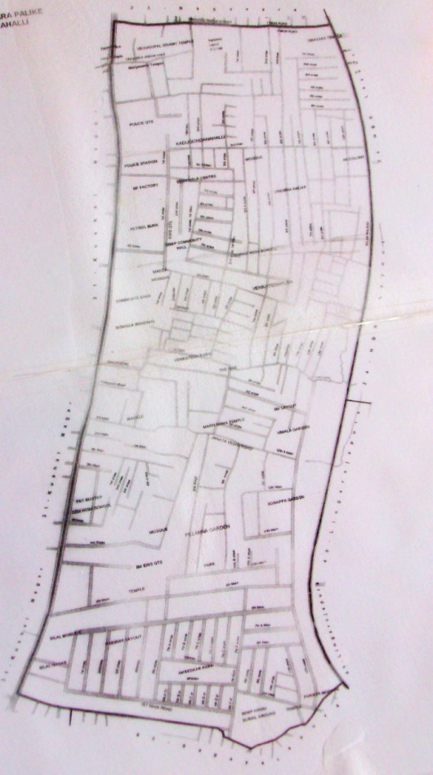

**Figure 1:** Map of KG Halli (Ward 30)

KG Halli has been the site for the Urban Health Action Research Project (UHARP) of the Institute of Public Health (IPH), Bangalore, since 2009. UHARP was launched with a mission to improve the quality of health care of KG Halli residents by working with the community, the local health services (private and government) and health authorities (13). Over the past five years the UHARP has been working with the community to understand their needs with the help of trained Community Health Assistants (CHAs). CHAs are trained by the UHARP team based on the ASHA modules, and they conduct regular house visits in the community, disseminating information about basic health issues, nutrition, hygiene, immunization and link people to the appropriate health services, under the supervision of UHARP staff when needed. UHARP’s other activities include facilitating a dialogue between the various stakeholders in the community to establish a common platform of health service provision, creating health awareness in the form of school health programs/rallies and promoting youth empowerment by establishing a community library and evening computer classes.

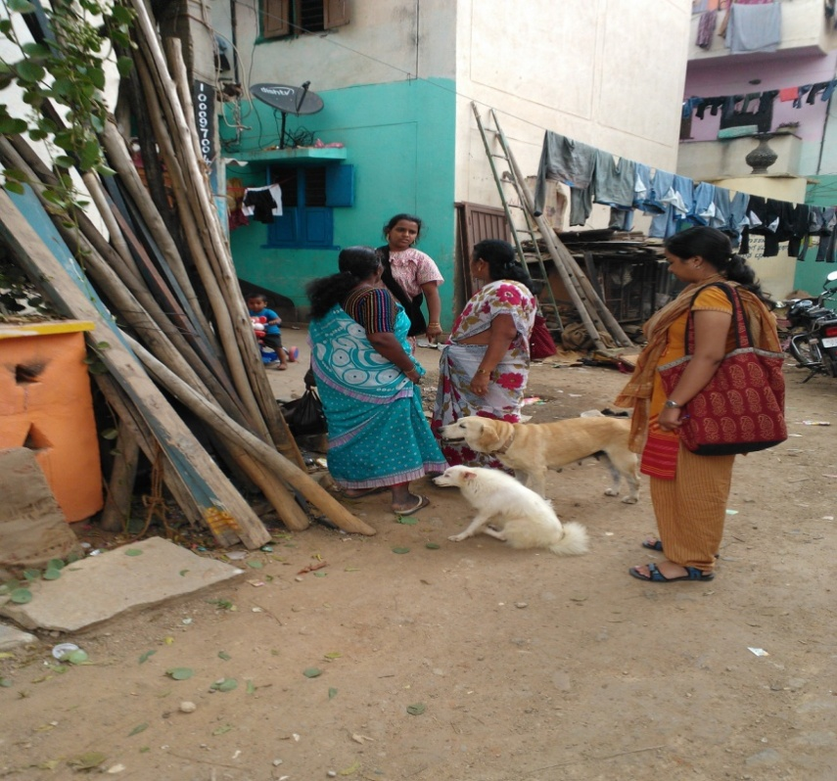

**Figure 2**: Community Health Assistant (CHA) interacting with the community

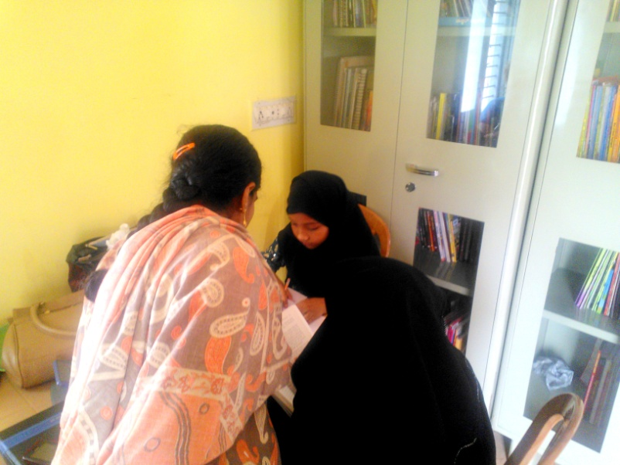

**Figure 3**: CHA helping children with their homework in the IPH community library

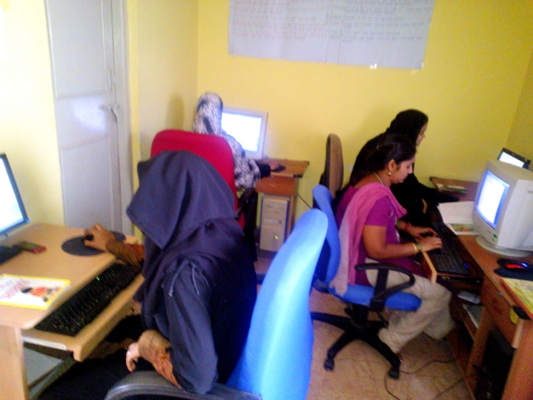

**Figure 4:** Computer classes in the IPH community center in KG Halli

An exhaustive census in the form of a house-to-house survey was conducted by UHARP in KG Halli between June 2009 and March 2010 to understand the socio-economic status and health-seeking behaviour of the urban community in the context of a pluralistic healthcare system. This self-reported census data showed, among all diseases, a high prevalence (13.8%) of chronic conditions in the adult population in KG Halli with 6.4% diabetes and 10% hypertension (16). KG Halli has a mixed healthcare delivery system with 2 government and 32 private health care facilities, most of which are small clinics run by general practitioners (GPs).

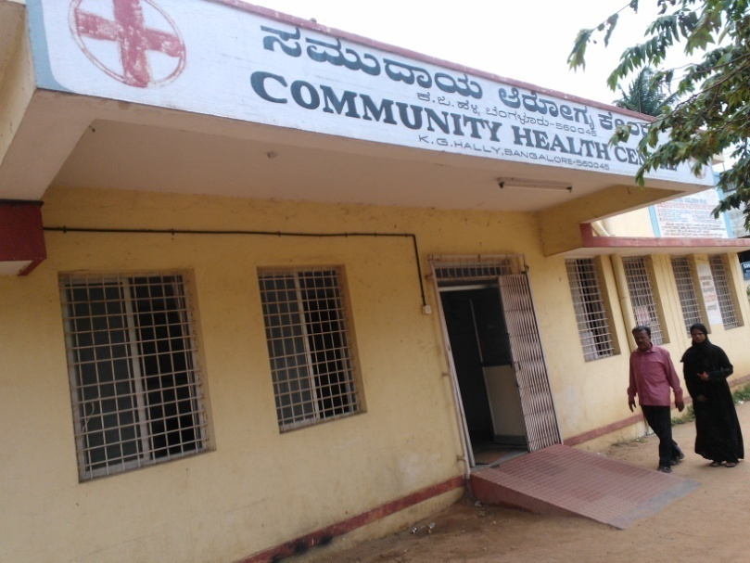

**Figure 4**: Community Health Center (Government CHC)

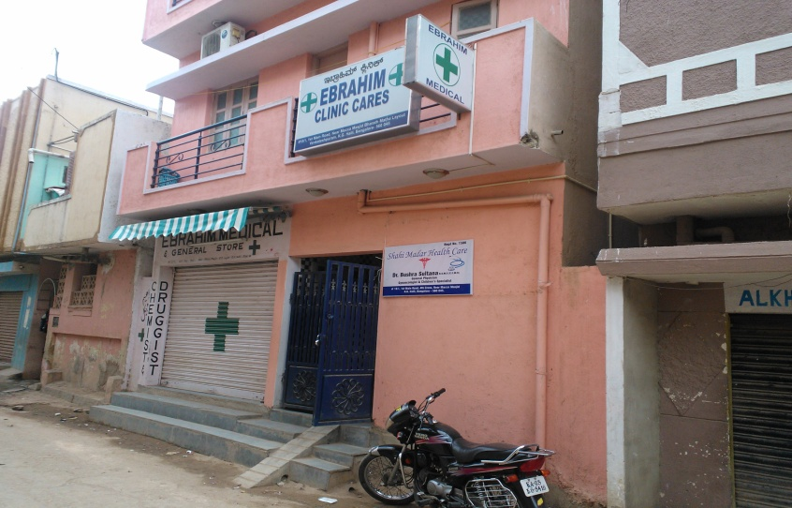

**Figure 5:** A private clinic and an adjacent pharmacy in KG Halli

69.6% of the surveyed households incurred high out-of-pocket (OOP) expenditures for chronic conditions with 16% families facing financial catastrophe by spending more than 10% income on OOP (12). This doubled the poverty rate every month (12). A subsequent study conducted in 2013 revealed that despite the vicinity of abundant healthcare centers, one of the major barriers to care reported by diabetic patients in KG Halli is financial hardship (8). The largest share of healthcare OOP has been on medicines, particularly in chronic care where medication needs to be taken for a lifetime (14). Other reasons that drive up the OOP are: the lack of medication and diagnostic services within government facilities, which forces patients to visit different private facilities for different components of care (8). Hence, all these services need to be integrated in one location in the public sector, the private healthcare sector costs should be regulated and financial protection must be provided to patients against huge impoverishing OOP costs (8).

When details of the study were discussed with the community and health providers, both the stake holders suggested that increasing the availability and accessibility of low-cost medicines would be the first step in dealing with this issue. Several negotiations were conducted with both the private health providers and the government facilities (CHC and UHC). However, the private health providers were reluctant to prescribe low-cost generic medicines since pharmacies in the area either did not stock generics or sold generics at the same price as brand medications. UHARP’s attempt to strengthen the existing government facilities saw no success because the requisites recommended by the government health facilities were not feasible for the project.

Therefore, the IPH Hypertension and Diabetes clinic (primary care clinic) was started by UHARP on January 6th 2014 as an experimental model to provide affordable, quality and patient-centric diabetes and hypertension care to the residents of KG Halli. The clinic operates every Monday, between 2pm and 5pm and offers free consultation and counseling services by trained medical doctors and nurses. The clinic also dispenses generic diabetes/hypertension medicines at a subsidized rate. The clinic is equipped with a BP monitor and finger-stick testing for random blood glucose monitoring. For the first three months, the clinic was staffed by a doctor from a Christian mission hospital in the area while IPH was only involved in procuring and dispensing medications. Presently, due to shortage of doctors from the mission hospitals, two UHARP personnel, who are trained medical doctors, operate the clinic while the Christian mission hospital continues to send nurses to the clinic.

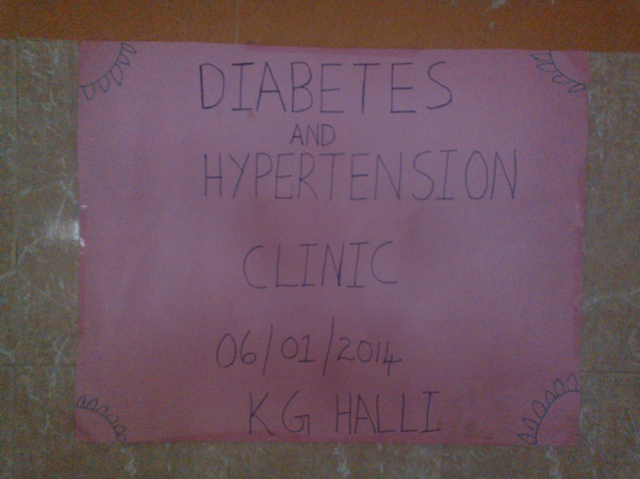

**Figure 6**: IPH Diabetes and Hypertension Clinic

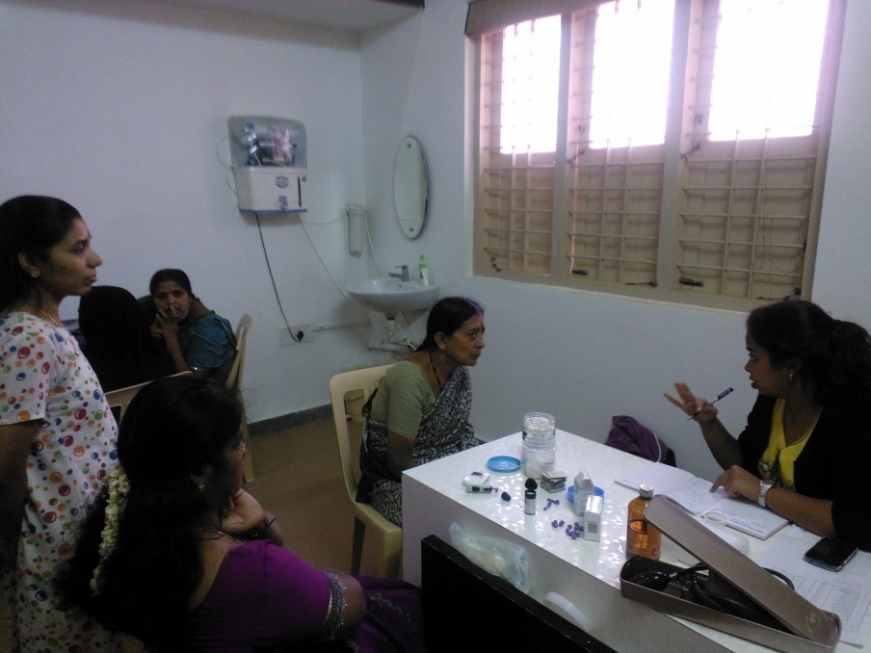

**Figure 7**: Doctor- patient interaction in the clinic

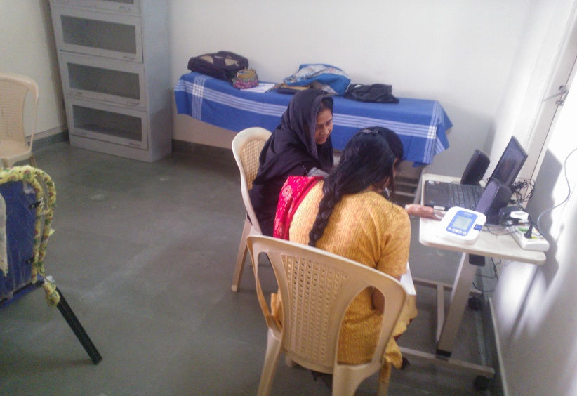

**Figure 8:** Patient counseling services

Among the slums in KG Halli, one particular slum, *Slum A*, was identified to be on the lowest rung of the economic ladder, with residents unable to make ends meet (Snapshots of Slum A in *Appendix 4*). Therefore, the UHARP team, along with the support from its funding agency, decided to offer free medicines to the people of this particular slum in addition to the other free services at the IPH clinic. The Community Health Assistants (CHAs) of UHARP who have worked closely with the community over the past four years identified 22 residents (as of May 2013) in *Slum A* who have diabetes and hypertension. The CHAs visited their houses, created awareness about the free services in the IPH clinic and gave “health cards” that qualified them for free medicines and insulin in the IPH clinic. These cards have information such as name of the patient, address, contact information and family member details.

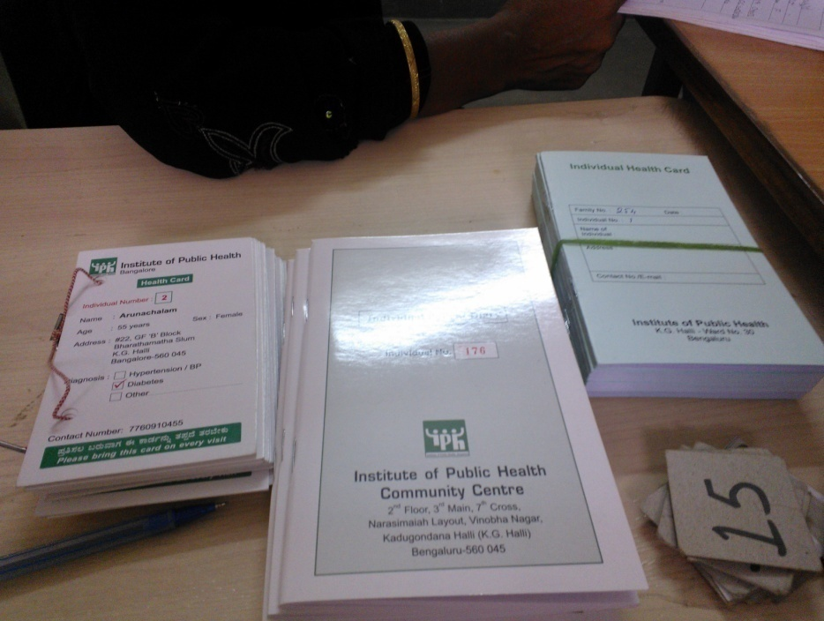

**Figure 9:** IPH Health Card and Patient Diary

Despite the expressed need by the community, awareness created by the CHAs in *Slum A* and the utilization of the IPH clinic services by residents from various other areas of KG Halli, only 6 out of 22 diabetic/hypertension patients of *Slum A* have come to the IPH clinic as of August 2014. Even among these 6 patients who visited the IPH clinic, only 2 patients visited more than twice and none have returned since March 2014. Currently, there are no patients from *Slum A* who are availing the services of the IPH clinic.

Therefore, there is a need for a systematic in-depth study to understand why the residents of *Slum A*, despite being promised free medicines and treatment at the IPH clinic, are not availing these services.

**Aim**

This study aims to explore and understand the potential barriers experienced by the residents of *Slum A* to access primary diabetes and hypertension care in the IPH clinic.

**Objectives**

* To identify the socio-economic, cultural, physical, structural and political barriers that are unique to residents of *Slum A* that prevent them from seeking diabetes and hypertension care in the IPH clinic.
* To understand the history of disease(s) in the diabetic and hypertensive residents of *Slum A*, their health-seeking behaviour and healthcare expenditure.
* To understand their perceptions regarding the quality of care at the IPH clinic and particularly explore their attitudes regarding generic medicines dispensed in the clinic.
* To list the learnings from the study that could benefit the UHARP team to modify the current functioning of the IPH clinic and improve the accessibility of diabetes and hypertension care to the residents of *Slum A* and KG Halli as a whole.

**Methods**

**Participants:**

A qualitative approach using in-depth interviews was adopted for this study. The study population comprised of people from Slum A who have diabetes and/or hypertension. The participants were identified using the following inclusion criteria –

1. Must be a resident of *Slum A*.
2. Must have diabetes and/or hypertension (self-reported).
3. Must have the IPH Health Card prepared under their name.

An exhaustive sampling approach was adopted to obtain all the viewpoints of the problems since the population size was small.

**Materials and Procedure:**

In-depth interviews were conducted in the households or any location within the neighbourhood of *Slum A* that was convenient for the participants. Sixteen in-depth interviews were conducted. The first six interviews were conducted by the Primary Investigator (PI) and one of the study supervisors. The next ten interviews were conducted by the PI alone. In order to avoid unnecessary distractions to the participants, the interviews were conducted in a relatively quiet location. Prior to the interview, verbal consent was taken from the participant if they were comfortable having family members, neighbours or others present during the interview. Apart from the participant, interviewer(s) and translator (CHA), all others were instructed to not intervene during the interview unless they acted as a secondary source of information. Informed consent was obtained from the family members who acted as a secondary source of information. Interviews were carried out using one of the following local languages – Kannada, Tamil or Urdu. A semi-structured interview format was followed using a topic guide *(appendix 1).* Prior to the launch of the full study, three pilot interviews were conducted in a neighbouring slum – *Slum B* which is also located in KG Halli and is comparable to *Slum A*. The final topic guide was evolved based on the preliminary responses in the pilot. The PI conducted the interviews in Kannada and partly in Urdu. Interviews in Tamil and Urdu were conducted with the assistance of a CHA who acted as a translator and translated the interview between Kannada and Tamil/Urdu *in situ*. Details of the study were explained in the language the participant could understand and the informed consent for participation was signed prior to the interview. If the participant was illiterate, a thumb print was obtained in the presence of a literate witness of the participant’s preference. With the consent of the participant, interviews were recorded using the SONY MP3 Digital Voice IC Recorder (Model: ICD-UX71F) owned by UHARP in KG Halli, Bangalore. If the participant was uncomfortable with the audio-recording, the PI instead wrote down the interview verbatim in a notebook after translating into English *in situ*. A soft-copy version of the English transcript was then prepared post-interview. All audio-recordings of the interviews, on the other hand, were translated from Kannada to English only after the interview and the soft-copy versions of the English transcripts were simultaneously prepared.

The data was analyzed thematically using Atlas.ti software. First, all the transcripts were coded using Atlast.ti and the preliminary codes were reworded/reviewed for any repetitions. Then, similar codes were organized into categories. Several iterations of this categorization were done until the final themes were recognized.

**Ethical Considerations**

Listed below are the four ethical principles for research and how the study addresses these principles –

1. **The Principle of Non-Maleficence:** The risks involved in this study were minimal and no harm to the physical, mental and psychological health of the study participant or the community is anticipated. The interviews were conducted in the comfort of the households or neighbourhoods of the participants as per their preference and thus,no physical harm was expected. Researchers were trained to conduct interviews with utmost respect to the participant’s emotional, mental and psychological wellbeing so as to not cause any unnecessary harm or distress.
2. **The Principle of Beneficence:** This study was undertaken with the intention of understanding the barriers to accessing free diabetes and hypertension care in the IPH clinic and in turn, proposing measures to address these barriers to improve the clinic accessibilityto the Slum A community. Although there were no direct monetary benefits from participating in the study, the information participants provide will aid in future research and activities that will contribute to improving the overall quality of care in their neighbourhood.
3. **The Principle of Autonomy:** Protecting the rights and dignity of the participants wasthe top priority throughout the duration of the study. Participantshad complete autonomy over the decision to participate in the study or withdraw their participation at any point during the study. At the beginning of the study, participants were provided with a written informed consent and details of the study were explained verbally in the local language. Even after the completion of the study, at any time in the future, participants will have the right to revoke their consent to use information obtained from them for present or future research purposes. Participants were clearly informed that they are not required to provide any reasons for these decisions and none of their decisions would jeopardize their relationship with IPH.
4. **The Principle of Justice:** All study participants were treated fairly and no discrimination was made on the basis of gender, age, color, socio-economic status, religion, language, caste or creed. The study protocol remained the same across the study population and no individuals or groups of people received unfair treatment. The risks and benefits of the study will be equally distributed.

**Additional details**

**Relationship with Participants:** Participants were treated as indispensable partners in research and their dignity was upheld at every stage of the study. Participants were chosen based on inclusion criteria that did not unfairly exclude any group of people from participating or receiving benefits of the study. Participation was completely voluntary and no methods of coercion or false promises were adopted to ensure participation. Participants’ time was respected and the duration of interviews did not exceed than what was necessary.

**Informed Consent:** Participants were provided with a written information sheet (*appendix 2*) detailing the study purpose and objectives, and their rights as autonomous voluntary participants. Information on what data will be collected, how it will be used and the risks/benefits of the study are also included. If the participant was unable to read, the information sheet was read out to the participant. Informed consent for participation in the interview, audio-recording and publishing the interview verbatim (*appendix 3)* was obtained prior to the interview. If the participant was illiterate, a thumb print was obtained in lieu of the signature in the presence of a witness who was of the participant’s choosing.

**Confidentiality:** Interviews were conducted in a location of the participant’s preference. To protect the privacy of the participant, apart from the PI and CHA, only those family members, neighbours or others identified by the participant were present during the interviews. Verbal consent was taken from the participant to allow them to be present in the interview. Audio recordings were made using the SONY MP3 Digital Voice IC Recorder (Model: ICD-UX71F) owned by UHARP in KG Halli. All audio-records were securely stored and accessed only by the UHARP team for research purposes. In cases where the interviewee declined to be audio-recorded, the hand-written interview transcripts were securely stored and access was restricted to the UHARP staff. At all times during the project, confidential data was handled only by the PI and the UHARP team. If the study results are published, any information that identifies the participants will not be made public. If the participant chooses not to have their words published verbatim (option provided in informed consent), measures will be adopted to refrain from quoting the participant in any publications. The participants retain their right to view at any time the information that is collected from them and the right to deny usage of their details.

**Serious Adverse Events:** While risks involved in this study are minimal, the only possible adverse event that could possibly occur is the breach of confidentiality of the study participant. Protecting the identity of the participants was of utmost priority during the entire study period and after. If any instance of violation of confidentiality is brought to the PI’s attention, the PI will consult with the supervisors and potential actions for recourse will be implemented immediately.

**Indemnity Issues:**

No monetary compensation was provided to the participants for partaking in the study. The study involves in-depth interviews conducted in the homes or neighbourhood of the participants. Due to the nature of the study, no physical risks were expected. Therefore, there was no necessity for insurance to compensate the participants.

**Statement of Conflict of Interest:**

There are no conflicts of interest to the best of the researchers’ knowledge. The researchers agree to comply with the relevant national and applicable international guidelines. The PI was not involved in any ongoing projects during the study period.

**Results**

The details of the sixteen interview participants are mentioned in *Table 1.* For the column titled “*Attended IPH clinic”* the number in parenthesis indicates the number of times the people have attended the clinic.

Out of the 22 people identified by the CHAs to be eligible for the IPH health card, 6 were not included in the study for the following reasons –

* 1 resident was not available for interview
* 2 residents were deceased
* 3 residents were wrongly identified as having diabetes or hypertension

The in-depth interviews were used to first understand issues related to the history of the disease, health-seeking behaviour and health expenditure of the participants in order to set up the context before exploring the constraints residents of *Slum A* faced in accessing the IPH clinic.

**History of disease and health-seeking behavior**

All the 16 participants interviewed had been diagnosed with either diabetes or hypertension for at least 1 year. The duration of disease ranged from 1.5 – 20 years with 4 participants having the disease for more than 10 years. All but 2 participants reported symptomatic disease detection i.e. they were diagnosed with the disease only after they experienced symptoms.

*“First I had dizziness and they took me to a private hospital. There they told me I had BP. There they gave me tablets for BP. I took BP tablets for 4-5 years. It was normal after that. Suddenly I had problems with my eyes and they took me to Bowring hospital. There they told me I had BP and sugar.”* [P5, female 77 years]

There was mix of healthcare facilities where the disease was first detected – participants went to both government and private clinics when they were first diagnosed. However, very few participants chose to continue treatment at government facilities and instead switched over to private providers either due to their own experiences at government hospitals or due to reviews they heard about private providers from others.

|  |  |  |  |  |  |  |  |  |  |
| --- | --- | --- | --- | --- | --- | --- | --- | --- | --- |
| **Table 1: Details of the interview participants** | | | | | | | | | |
| **Participant No.** | **Age (yrs)** | **Sex** | **Diseases** | **Duration of disease (yrs)** | **Interviewer** | **Language of interview** | **Religion** | **Occupation** | **Attended IPH Clinic** |
| P1 | 45 | F | DM | 15-20 | AP and MG | Kannada | Hindu | None | Y (2) |
| P2 | 43 | F | DM | 6 | AP andMG | Urdu | Muslim | Beedi-maker | Y (1) |
| P3 | 55 | F | DM and HTN | 15 | AP andMG | Urdu | Muslim | None | Y(4) |
| P4 | 56 | F | HTN and DM | 5 | AP andMG | Kannada | Christian | Rag-picker | N |
| P5 | 77 | F | HTN and DM | 2 (DM) 5 (HTN) | AP andMG | Urdu | Muslim | None | N |
| P6 | 50 | M | DM | 2-3 | AP andMG | Urdu | Muslim | Faith-healer | N |
| P7 | 55 | M | DM | 3 | AP | Kannada (primary) Tamil (secondary) | Hindu | Construction worker | Y (1) |
| P8 | 60 | F | DM and HTN (both under control) | 1.5 | AP | Kannada | Christian | Hospital cleaning staff | Y(2) |
| P9 | 59 | F | DM and HTN (HTN under control) | 2 | AP | Urdu | Muslim | None | N |
| P10 | 50 | F | HTN | 6 | AP | Urdu | Muslim | Clinic cleaning staff | N |
| P11 | 48 | F | HTN | 16 | AP | Kannada | Hindu | Beedi-maker | N |
| P12 | 42 | F | HTN | 7 | AP | Kannada(primary) Tamil (secondary) | Hindu | Office cleaning staff | N |
| P13 | 38 | M | DM | 8 | AP | Kannada | Hindu | Domestic worker | N |
| P14 | 70 | M | HTN | 20 | AP | Urdu | Muslim | None | N |
| P15 | 70 | F | HTN | 4-5 | AP | Urdu | Muslim | None (begs alms) | N |
| P16 | 55 | F | DM and HTN | 5 | AP | Urdu | Muslim | None | Y (2) |

DM – Diabetes Mellitus, HTN – Hypertension, AP – AnushaPurushotham, MG – Mrunalini Gowda

Following their diagnosis, participants exhibited diverse health-seeking behaviours. Some took medications daily and visited their doctors for regular checkups (once in 1-3 months) but most saw their doctors only when they experienced severe symptoms. Adherence to medications depended on many factors, predominantly the availability of money to buy medicines or the presence of symptoms. Such patients chose to either alter the dose of medication or completely stop taking medications on their own without consulting a doctor. Some missed taking medications at times because of forgetfulness.

*“1-2 days I miss until they give me money for the tablets.”* [P16, female 55 years]

*“When he gets dizzy, he eats. When he does not get dizzy, he won’t eat.”* [daughter-in-law of P14, male 70 years]

Another interesting theme that emerged was many people reported that they had little awareness about the disease when they were first diagnosed and thus, neglected taking medicines properly. Once their symptoms became severe, they realized the consequences of not complying with treatment and later started taking medicines regularly.

*“I took tablets. I did not know much about the tablets that time. I did not know what problems could arise. Very carelessly I stopped. I used to take it when they gave the tablets and then stop. Only after I started having problems, I took some care and started taking insulin.”*(P13, male 38 years)

**Healthcare expenditure**

Patients spent approximately between Rs.100 and Rs. 500 per month for diabetes or hypertension medications alone, with the highest expenditure being Rs.2000 per month. Only 2 of the 16 participants were using free medicines from the government. In addition to medications, patients spent between Rs. 70 and Rs. 500 for doctor’s fees and lab tests. Some patients reported that their family doctors sometimes waived consultation fees or lab fees in consideration of their financial difficulties.

*“Sometimes they take Rs.50 also from me. They know us, poor people. He doesn’t take from us.”* [P2, female 43 years]

People had several ways for bearing their healthcare expenses, the most common being financial support from their family members. The second most common source of payment was through their earnings. Since most participants worked in the unorganized labour sector and earned daily wages depending on the availability of work, this income flow was variable. The last source of finances people resorted to was borrowing loans, especially during episodes of hospitalization when huge expenses were incurred.

*“What to do, my kids give me and I take it. I have 3 sons. If they give me, then it will be enough for our spending.”*[P6, male 50 years]

*“I go to the clinic for work, right? They give me 500 rupees per month. I use that for tablets and all.”* [P10, female 50 years]

*“I beg for alms in the masjid. I don’t have anyone to take care of me.”* [P15, female 70 years]

*“We had to take loans from here and there. We have to. What else to do?”* [Wife of P7, male 55 years]

Most people expressed that the financial burden of their diabetes or hypertension care placed a huge strain on themselves and their families. With this understanding of the residents of *Slum A*, the interviews proceeded further to explore the constraints they experienced in accessing the IPH clinic that provided them with free primary diabetes and hypertension care.

**Barriers to accessing the IPH clinic**

The findings that emerged from the analysis of the 16 in-depth interviews in exploring the barriers to accessing the IPH clinic have been divided into 7 main themes. Relevant sub-themes under these main themes are also included.

***1. Inadequate awareness about IPH clinic***

***Patient does not know anything about the clinic***

Lack of awareness about the IPH clinic was a significant theme that emerged during the interviews. When asked about the clinic, patients were either completely unaware of the clinic or they had partial/wrong information about the clinic. Out of the 16 people we interviewed, 4 people reported having absolutely no knowledge about the IPH clinic. It was the first time that they had even heard of the clinic or that it provided free medicines/services. 3 of these 4 were not given IPH health cards and thus, this could be the most probable reason for their lack of awareness about the clinic.

*“No, I did not know. I found out just now.”* (P13, male 38 years)

***Patient does not know where the clinic is located or does not know the timings of the clinic.***

People, who had heard about the clinic and had the card, did not know where it was located. They were confused about the location of the clinic or stated other primary reasons that prevented them from taking the effort to know about the location of the clinic. Some people also were unsure about the timings of the clinic.

*“I came twice to the address you told me and I looked there. I did not find the clinic, so I went again to Bowring.”* (P5, female 77 years)

*“She told me and gave me the card and all. I myself have not gone. I didn’t get time and didn’t know how to go there.”*  (P12, female 42 years)

**Patient confused about IPH clinic and other organizations**

There are several NGOs that work in *Slum A* on health and other related issues. Hence, people tended to confuse IPH with these other organizations. Due to the proximity of the government Community Health Center (CHC), which is located less than a kilometer away from the IPH clinic, some patients also confused the IPH clinic with the CHC.

*“No, my daughter went there for delivery. Also took the kids for checkup. Near the police station. They check the weight of the kids.” (Participant talking about the CHC when asked about what she knows about the IPH clinic) [P10, female 50 years]*

# *2. Inadequate follow-up/misidentification of patients by Community Health Assistants (CHAs)*

***Timings of the CHAs not matching with the availability of patients***

Lack of communication between the CHAs and some sections of the community was a critical barrier that emerged during analysis of the interviews. Mismatch in the work timings of the CHAs and the people proved to be a major reason for this inadequate communication. The CHAs visited the community between 10am and 5pm on weekdays and therefore, missed out on interacting with many people who went out for work during the day.

*“They [pointing to CHA] also come and when they come to check, I am not there. That is the problem.”* [P11, female 48 years]

***No health card given to some patients***

6 out of the 22 identified patients were not given the IPH health cards primarily due to the reasons mentioned above. Although the cards were printed with their names, they were not distributed to the patients. Among the 6 patients with no cards, 1 reported partial awareness about the clinic since the CHAs spoke to her while surveying the area, 1 patient was deceased and 1 patient was not available for the interview. The remaining 3 patients said they had no knowledge about the clinic. These were the same patients mentioned in the theme titled *“Patient does not know anything about the clinic.”*

*Interviewer: “Did you get a card? [Pointing to a IPH health card that we had] Like this, did someone give you a card?”*

*[P10, female 50 years]: “No, no. No one gave.”*

***Lack of follow-up by CHAs***

Although a majority of the people mentioned that they recognized the CHAs and that they visited them many times, few people reported rarely seeing or interacting with the CHAs.

*Interviewer: “You did not find the clinic. Did you tell anyone among the three of them (CHAs) that you did not find the clinic?”*

*(P5, female 77 years): “No, no one came.”*

***Wrong identification of patients***

3 of the 22 patients were wrongly identified as having the disease (DM and/or HTN). This was due to the inadequate understanding of the disease symptoms by both the patients and the CHAs.

***3. Perception of medications***

The 6 participants who had been to the IPH clinic at least once had a general positive opinion about the clinic and the staff. Most of them recounted that they were counseled about their disease and information was given about self-care, exercise and diet. They also said that the doctors and nurses were friendly. Overall, when asked about their experience in the clinic, people mostly said “good.”

*“The doctors come and check sugar and BP. They tell this and that. They tell that it will become better… Yes, the computer is there no. In that they told me to see. They show for 15-20 mins and I have seen it… “You have the disease. Do this, be proper and take care of yourself. Take care of your health,” it says all of this.”* [P15, female 70 years]

However, when probed further, people felt that although the clinic was “good”, they had a problem with the medicines dispensed. Perception of the generic medications dispensed in the IPH clinic was one of the major reasons that people cited for not accessing the clinic. People formed different opinions about the medicines either through their own experience of consuming the medicines or were influenced by others.

*“It (IPH clinic) was good. There were a lot of people. I thought, “Let me go see.” So I went there. When the (private) doctor told me that the medicine did not suit me, “Don’t eat this, ma, this other medicine. Use whatever you used before.” I stopped taking it and I am using this only.”*[P1, female 45 years]

***Experiencing side-effects***

Of the 6 patients that came to the IPH clinic, 2 patients reported side-effects from the medicines. Patients reported taking the medicines for at least one month before they started experiencing side effects and felt that their disease was not under control.

“*I took for one month. Nothing happened. I took the next month. After eating, BP and diabetes both became high. I became weak – hands and legs. ……There was burning here. And then the whole feet. I put on vicks, I put on iodex. I put on a turmeric cloth. Afterwards, with iodex it became less. The pain.”*[P3, female 55 years]

***Family doctor’s perception about the effectiveness of the medicines***

When patients showed IPH medicines to their family doctors, the doctors informed them the medicines were ineffective and they needed to revert back to their old medicines. The trust in their family doctor’s opinion influenced patients to stop coming to the IPH clinic.

*“I went to [Private] Clinic and they said, “Power is less in these tablets. You take this only. That does not suit you.”* [P3, female 55 years]

***Poor quality of medicines***

One patient reported that the medicine became powdery when she tried to open it. She complained of no side-effects, however. The patient insisted that this was the main reason for not coming to the clinic and she would come if the clinic gave “good medicines.”

*“No pain or anything.That medicine, it would become just like a powder. Like a powder. When I ate, I didn’t feel right…. If you give good medicines, I will come*.*”* [P16, female 55 years]

***Experience of neighbours***

One person in the community fell ill and was hospitalized. Word spread in the community that the IPH medicine was the cause of this incident. People began discussing among themselves about the experiences they had or heard from others about IPH medicines and came to the conclusion that the medicines were not suitable for anyone.

*“They all ate no. It became more for all of them. That old lady was admitted for 5 days in the hospital. Then I thought we don’t have money with us right now to get admitted. All our money went away. We don’t have anything. We earn money and eat. That is why I didn’t eat any tablets because I was scared.”* [P2, female 43 years]

***Fear of changing to a new healthcare facility or medication***

Among the people who had heard about the IPH clinic but had never been to the clinic, their preference and trust in their current healthcare provider far outweighed the monetary benefits of trying a new free clinic. People went on to say that they would only come to the IPH clinic if they received the same brand of medicines that they are currently taking.

*“My mind tells me, “Don’t take any other medicines. Continue this tablet only.” That is why I take this only… I have been going since 20-30 years to [Private] clinic. That is why I will not take it anywhere else. If I eat anything else, after eating my face becomes like this [puffs up her cheeks]”* [P15, female 70 years]

*“If you give us tablets, I will come. If you give us our tablets, we will come.”* [P2, female 43 years]

***Mistrust in government health facilities and confusion about IPH clinic as a government facility.***

Most people expressed mistrust in government facilities either based on their own experiences or experience of others. Due to the inadequate awareness about IPH clinic and the perception in people’s minds that “free medicine” is synonymous with “government medicine,” people were skeptical that the clinic dispenses poor quality “government medicines.” Therefore, they refrained from coming to the clinic altogether.

*“…thinking that government tablets don’t suit me either, even I didn’t eat. I never take government tablets. My stomach starts burning and my health gets bad….. The old lady said that “It is free, government medicines.””*[P2, female 43 years]

***4. Distance***

***Unable to walk the distance to the clinic and afford extra cost of travel***

Distance was a physical barrier that people reported in accessing the clinic. The clinic is located about <2 kms away from the neighbourhood and while some felt that this was within walking distance, many said that they need to take the bus or the auto to come to the clinic. Most of the diabetic patients complained of pain in their feet which made it even harder for them to walk the distance to come to the clinic. People who felt that the clinic was too far cited the extra money for traveling was a constraint from coming to the clinic.

*“I came back and told her [looking at the CHA] that “I am not coming. I can’t go that far. If I go walking then my feet hurt. My feet hurt all night.”*[P3, female 55 years]

*“I will come to get the tablets if you can help with the travel to and from there.”*[P14, male 70 years]

***Other health facilities are closer***

Due to the abundance of many private clinics in the vicinity that had established trust with the community, some people preferred continuing to seek care in those clinics as they found the location of the IPH clinic inconvenient.

“I go walking. It is close by. Behind.”(when talking about her current clinic)[P3, female 55 years]

***5. Restricted Timings***

***Clinic timings conflicting with work timings***

In addition to the distance, timing of the clinic was an important limiting factor that decreased the accessibility. The clinic is open only on Mondays, between 2pm and 5pm. This restrictive timing prevented people who go to work during the day from accessing the clinic. Majority of the patient population who work were daily wage labourers and hence, taking even a day off amounts to the loss of a day’s pay.

“The timing doesn’t match. If I don’t go to work for a day, they cut the wages. That is why. There if my wages get cut..” (P12, female 42 years)

***Other health facilities with more convenient timings***

Other private health facilities in the area were open for longer hours - during the evenings and sometimes, even on weekends. This made it convenient for people to access the clinic after work and thus, they preferred these clinics over IPH clinic.

*Interviewer: “What time do you go to [private] clinic?”*

*[P11, female 48 years]: “I go in the evening, amma…. I have not gone (to IPH clinic) because I don’t have time, that’s all.”*

***6. Health-seeking behaviour***

***Attitude about own disease***

The past health-seeking behavior of the respondents gives some insight into why they decided against coming to the IPH clinic. Many people felt that they needed to go to the doctor only when they had symptoms and there were long periods of time (6months – 3 years) when they would not see any doctor. Some of them did not have a preference for any particular doctor and would seek treatment at any facility that was convenient at the time of illness. Therefore, since such patients had not experienced any severe symptoms recently and did not feel the need to go to a doctor, they might not have come to the IPH clinic.

*“I go anywhere and everywhere…. I have it (tablets), I buy that and eat*…..*If I get fever, cold or body aches, I would go. If not, I would not go.”* [P12, female 42 years]

Among the others who exhibited irregular health-seeking behaviors, some had accepted that death was inevitable, so they did not feel the need to comply with their doctor’s instructions or take medications regularly.

*“Anyway, one day we all should die, so leave it” thinking that I stopped (taking tablets*).” [P7, male 55 years]

Among the 16 participants, only 1 mentioned that her diabetes and hypertension were currently under control and since she was told by several doctors that she did not need any medications, she stopped coming to the IPH clinic. This patient showed a high level of understanding about the disease and strictly adhered to the treatment regimen and diet. She continues to get her sugar and BP levels monitored monthly.

*“After I got diabetes I became very scared. After that I went to so many places and got my blood checked, do you know? Any place people told me I went. Even when they say pay Rs.50 and get it checked, I would. The reason being, in (private) hospital I see, right? Hand amputation, leg amputation and all that! That is why I used to get it checked regularly. I was afraid. That is why now I don’t have anything. It is normal.”* [P8, female 60 years]

***Source of payment of health expenditure***

Some patients said that the only reason that they were able to afford the cost of the medications and treatment in private clinics was because they were receiving financial assistance from their family members or from their place of work. If they did not receive this support, they would have come to the IPH clinic for the free medicines.

*“I don’t pay. The people whom I work for, they pay... They give me money and I buy it. Fees whenever I go to the doctor I only pay 100 rupees. For tablets they give…*

*[Speaking about what she will do if her employer doesn’t pay for medicines]*

*I have to pay or my kids have to. Otherwise I have to go to this [IPH] clinic. That is what. I am talking about it openly. If they did not give me, my kids get salary every month otherwise I have to go to this clinic. To them only [pointing at the CHA].”*[P11, female 48 years]

***Alcoholism***

One of the respondents reported that his habit of drinking alcohol was the main reason that prevents him from coming back to the IPH clinic. Although he did not admit it himself at first, after much discussion, his wife informed us that he is afraid to take diabetes medication while drinking alcohol as he is aware of the ill-effects of mixing the two. Despite being hospitalized twice due to complications from diabetes, he chooses to not comply with the treatment.

*P7’s wife: “If he takes the medicine, he won’t be able to drink liquor. So that is why he stops.”*

*[P7, male 55 years]: “Yeah, that is the reason. Nothing else.”*

The wife went on to tell us the various measures, including faith healing that they have taken to stop his alcoholism in vain. The entire family, including the children, has supported him to rid himself of the habit and convinced him to take care of his health.

*“We have tried so much, madam. He promises on all of us. He even promises to God. When he goes to the hospital what he tells, “From today onwards I won’t drink. There are a lot of difficulties at home.” He thinks about all of this when he is on the hospital bed. When he comes back home, he goes back to it. What to do? That is why we don’t send him to work, we ask him stay at home itself. If he goes out for work and earns money, he will drink. That is why we don’t send him.”* [P7’s wife]

The patient on the contrary feels like he can stop drinking whenever he wants if he makes up his mind. He states that he has stopped drinking in the past for as long as 6 months when he was hospitalized. Therefore, he can stop anytime and come to the clinic.

*“I don’t have anything like that, madam. For everything it is my mind that is the reason. If I want to stop then I can stop, I am like that…. When I take medicines, I will be afraid that I can’t drink, right. If I stop taking meds only then I drink. If I take meds, I can’t drink right.”*

Despite the patient’s confidence, his wife felt less assured about the promise because the patient had been recently discharged from the hospital but had already returned to his drinking. His alcoholism was deeply rooted and she felt they needed more assistance to tackle the problem effectively.

***7. Family Structure***

Family dynamics also played an important role in the decision-making of the patients when it came to choosing their health-care facilities. Majority of the patients said that they had very supportive families who gave them complete autonomy over any decisions they made regarding their health. Their families did not influence them to choose one health care facility over the other or discourage them from going to the IPH clinic. However, there were other subtle familial factors that indirectly became barriers to accessing the clinic.

***Need someone to accompany to the clinic***

This was a significant theme that emerged among the elderly patients we interviewed. Older patients depended on family members to take them to the clinic and if no one was available to accompany them, they would not be able to go anywhere. If the clinic was too far, they would instead prefer a closer clinic so that it would be more convenient for their family members. Thus, these patients did not have complete independence to choose when and where they wanted to go for treatment.

*“I have pain in my feet, so I can’t go anywhere. Also, my grand-daughter is too young to take me to the clinic. My daughter stays at home with her 5 children and she cannot take me. My son goes to work and my daughter-in-law also has 5 kids. I went in auto 2-3 times to the clinic with 2-3 people. Because they stopped, I also stopped going. That is why I stay at home itself.”*[P16, female 55 years]

***Lack of communication between family members***

When the CHAs distributed the IPH health cards, some cards were given to the patients’ family members and not directly to the patients (if they were unavailable or at work). This sometimes resulted in the message not being conveyed to the patients because of the lack of communication within the family and thus, the patient had little or no awareness about the IPH clinic.

*“No, she (wife) did not tell me. She has her own tension at work. In the morning she has to take care of the kids. I only come at 9-9:30 at night. I eat dinner and sleep. That’s all.”* [P13, male 38 years]

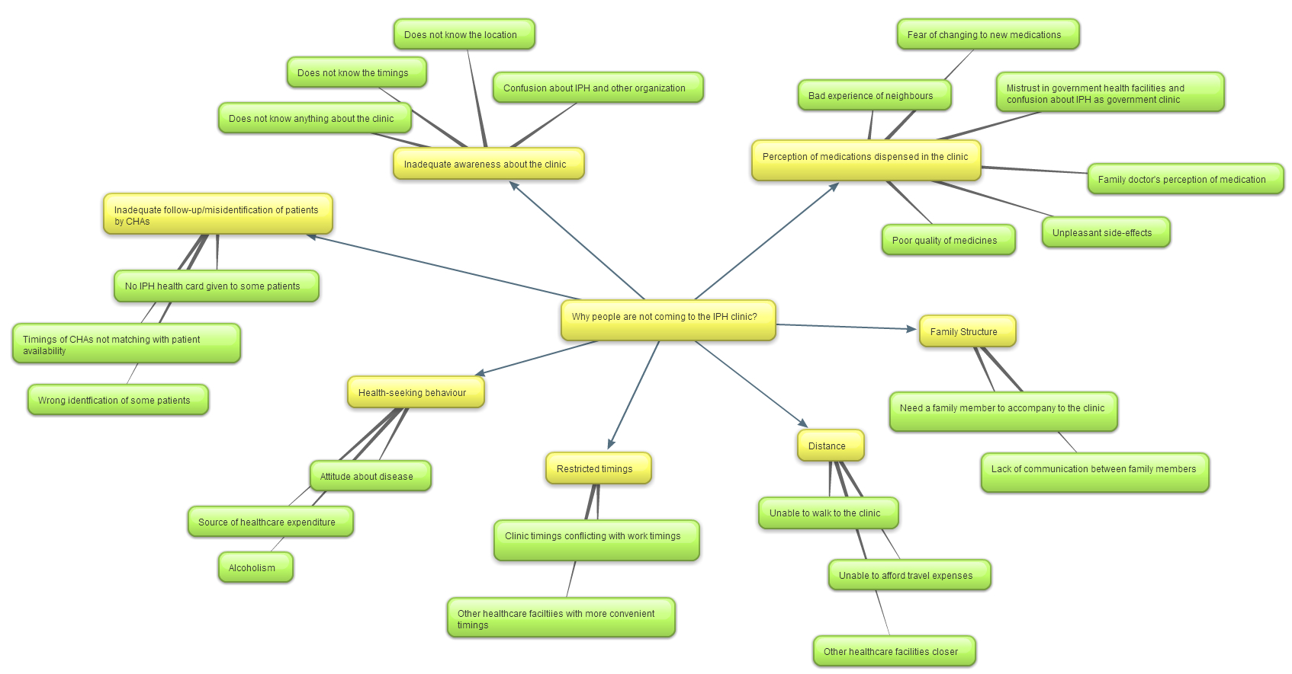

**Figure 10- Schematic diagram representing the major themes of why people are not accessing the IPH clinic:** Thematic analysis of the 16 in-depth interviews showed seven main barriers that prevent people from accessing the IPH clinic. The major themes are represented in yellow and the sub-themes under each major theme are represented in green.

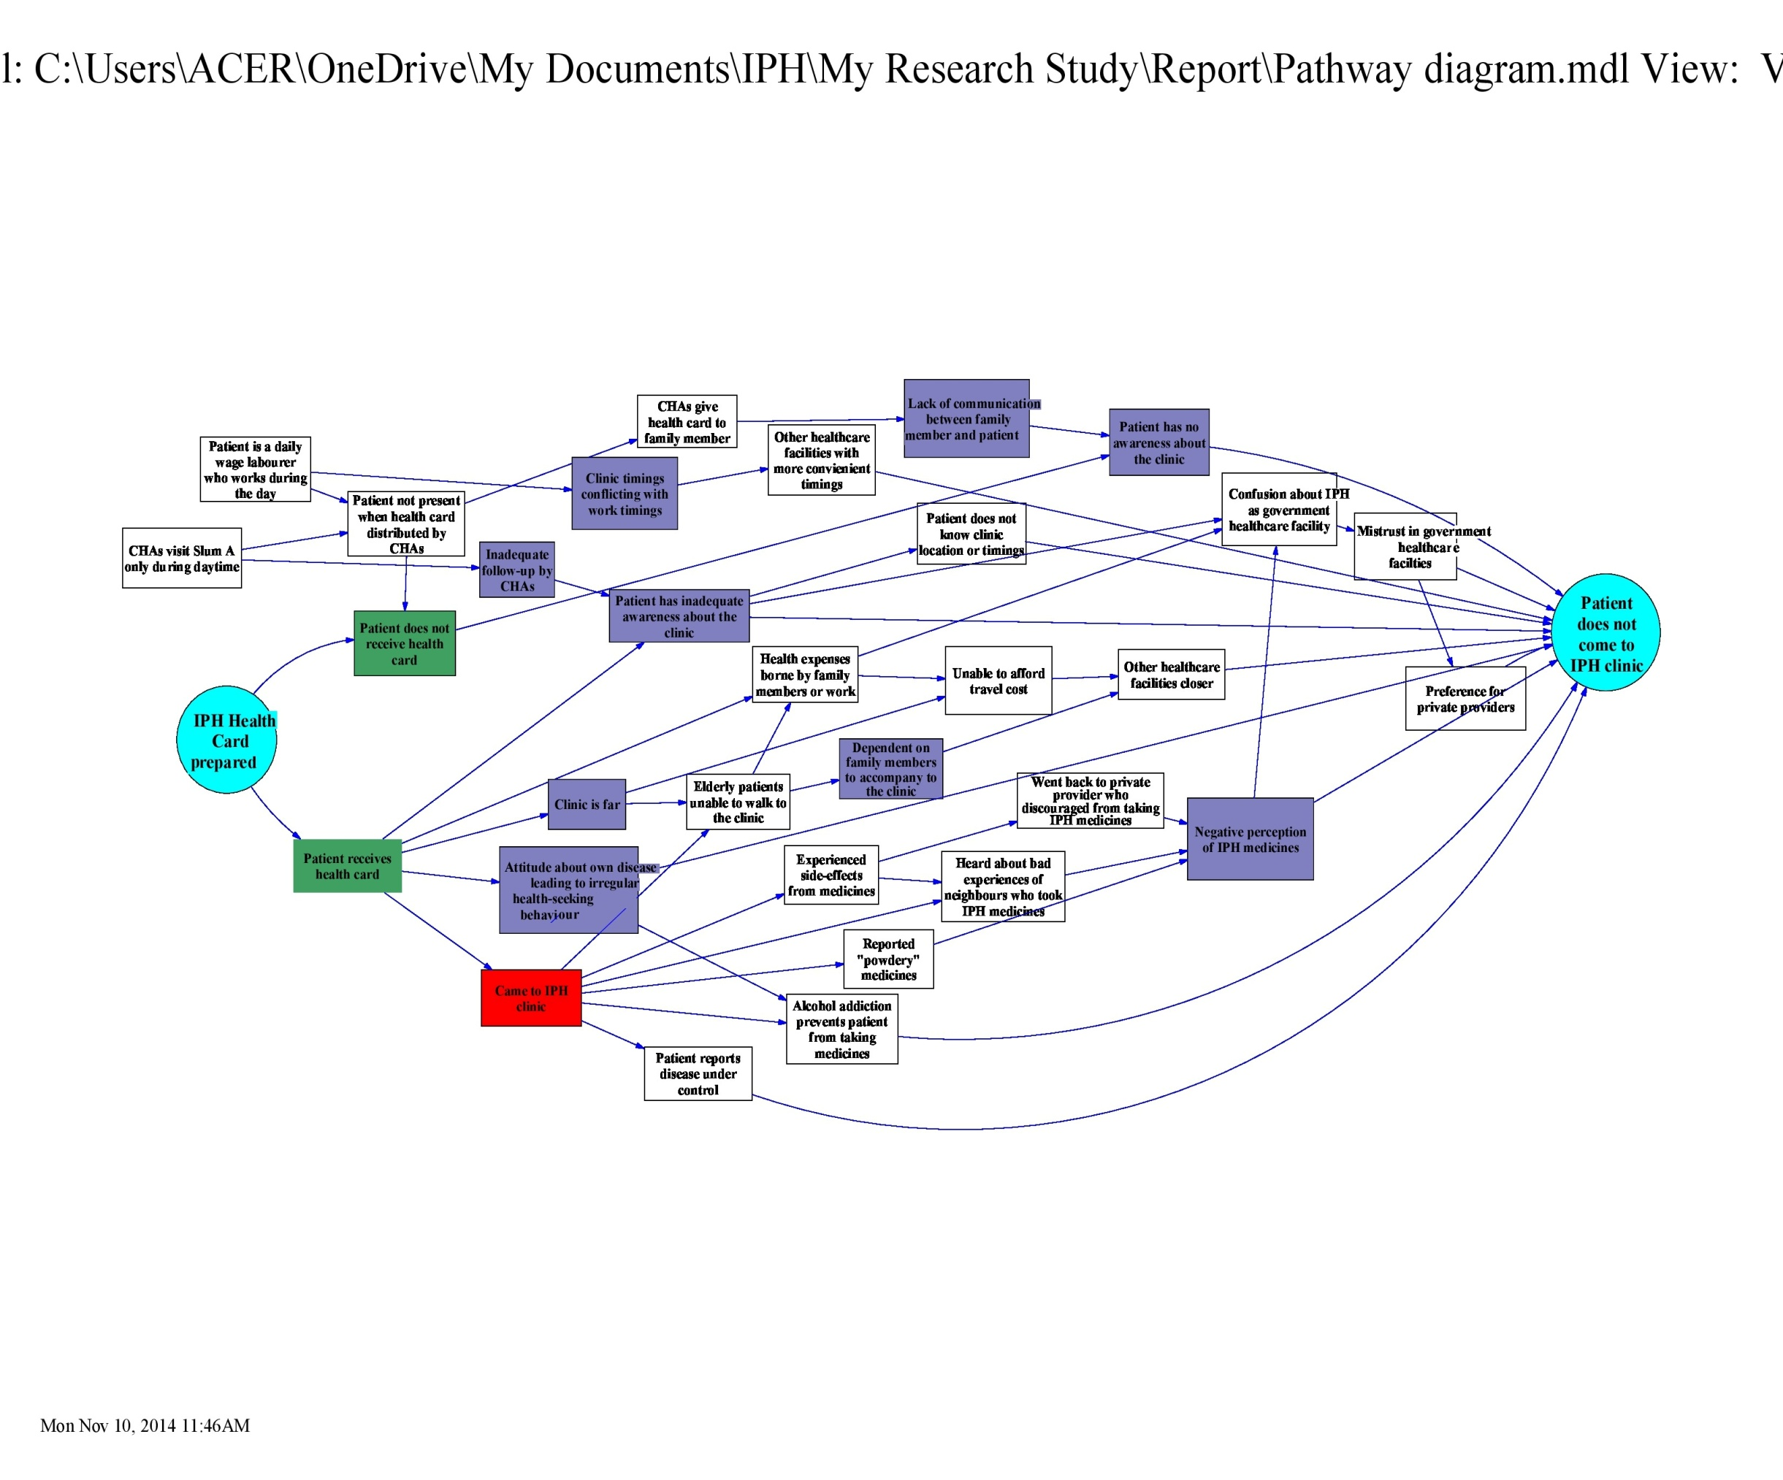

**Figure 11 - Pathways elucidating why people from Slum A are not coming to the IPH Clinic:** This diagram captures the various pathways from the starting point – ***IPH health* card is prepared** to final point – ***Patient does not come to the IPH clinic***. These are tentative pathways that explain why people from Slum A who were identified to have diabetes and/or hypertension are not coming to the IPH clinic. The two main scenarios are that the patient either receives the IPH health card or does not receive the health card. Based on these two situations, different pathways can be traced. The seven major themes – lack of awareness about the clinic, inadequate follow-up by the CHAs, negative perception of the IPH medicines, timings, distance, health-seeking behaviour and family structure are highlighted. This diagram illustrates that the 7 themes are not acting in isolation but are interlinked.

# *Discussion*

With the intention of addressing the financial burden of medications and thereby increasing compliance and continuity of treatment in diabetes and hypertensive patients, IPH set up a clinic in January 2014. Despite their eligibility to receive free medicines and treatment, the residents of *Slum A* reported several constraints that prevented them from coming to the clinic. This study describes these barriers: lack of awareness about the IPH clinic, inadequate follow-up/misidentification by CHAs, perception of IPH medications, distance, restricted timings, health-seeking behaviour and family structure.

Lack of awareness about the IPH clinic was one of the major themes that emerged in the study. This goes hand-in-hand with the next barrier - inadequate communication between the CHAs and the community. Some patients said that they did not know specific details like timings/location of the clinic while others stated they had never heard of the clinic. In order to further understand this implementation gap, informal discussions were conducted with the three CHAs who worked in *Slum A*. All three CHAs (including a fourth one who is no longer with IPH) had surveyed *Slum A* in September 2013 to identify the diabetes and hypertensive patients in the area but only 2 of the CHAs went in January 2014, just before the opening of the clinic, to distribute the health cards. Some houses were missed since they were locked during the survey and/or card distribution. The CHAs reported that these houses belonged to daily wage labourers who worked during the day. Although they went back again 2-3 times to the same houses, even during the weekends, they were still locked. Therefore, 6 patients who were identified during the survey were not given health cards because the CHAs only went to *Slum A* during the daytime. These patients with no cards mentioned that had they been aware, they would have come to the clinic to receive the free medicines.

A possible suggestion to tackle this problem of mismatched timings between the CHAs and the community would be for the UHARP team to consider modifying the work timings of the CHAs such that they can visit *Slum A* in the evenings for few days a month so as to reach out to this section of *Slum A.* This could also address the issue of lack of awareness about the IPH clinic and inadequate follow-up by CHAs since the CHAs would have more opportunities to periodically interact with the all/or most of the patients from *Slum A* in the evenings, receive their feedback and listen to their concerns.

During the study, it was also discovered that 3 patients were wrongly identified by the CHAs to have the disease(s). The CHAs stated that when they conducted the survey, patients who reported that they had the disease(s) gave a different answer when they were interviewed for this study. Upon further probing, we attributed this oversight to the lack of understanding of disease identifiers by the CHAs and patient confusion about their own disease. Therefore, there is a need for further training and monitoring of the CHAs so that they are able to spend more time with patients and have better knowledge about the specific questions they need to ask before identifying patients.

Perception of IPH medications was another significant constraint. Experiences of neighbours or personal experiences of side-effects from IPH medications made a huge impact in people’s minds and thus, patients refrained from taking IPH medicines. Further investigation is needed on this topic to understand why these patients experienced unpleasant symptoms, if these symptoms are truly side-effects of the generic medicines and what the quality of the generic medicines was in comparison to their branded counterparts. A possible explanation, if the side-effects are confirmed to be true, is that the generic drugs may have inactive ingredients that are not suitable for these particular patients (17).

The poor opinion of other general practitioners’ in the locality regarding the effectiveness of generic medicines dispensed in the IPH clinic played a huge role in influencing patients’ perception about the medications. Informal discussions with the CHAs revealed that these physicians were usually linked to local pharmacies that sold only branded medications and thereby, generic medicines were not preferred by either the pharmacists or the physicians. This finding is consistent with another study conducted in South India, which showed that community pharmacists and drug retailers had negative perceptions of generics either due to low understanding about generics or preference to dispense branded medicines that met the largest profit or incentive payments (18). The attitude of these professionals proves to be a critical barrier to generic drug usage and calls for effective policies at a state or national level to tackle this issue and promote the use of affordable rational therapeutics. At the community level, innovative efforts can be re-initiated with health practitioners to support the use of generic drugs.

Most people who never came to the clinic confused IPH medications with “government medicines.” They had pre-conceived notions that “free medicines” were “government medicines” and thereby, were of “poor quality” and did “not suit them.” The CHAs too recognized this issue during their field visits and stated that patients do not value the medicines because they are given free of cost. Patients have told them repeatedly that they are willing to come to the IPH clinic only if they are given branded medicines. None of the patients identified these medicines as “generic” and this could be possibly due to the lack of knowledge regarding generics. Among those we interviewed, only two patients and their family members felt that “government” and “private” medicines were equally effective.

Some of the older patients were afraid of switching over from a known drug that they had been using for several years to an unknown drug. All these patients, despite their financial difficulties, were willing to spend money and buy what they called “good” medicines instead of risking eating other medicines. When asked how we could help, they asked that we provide them with either these “good” medicines or give them money to buy those medicines. Therefore, this suggests a pressing need to remove the stigma around government/generic medicines and create more awareness and trust among people regarding their benefits. There are very few studies in the Indian context that explore patient’s perception of generic medicines (17) and the findings presented in this study from a patient’s perspective is an important contribution to this growing database of knowledge.

The work timings of many people conflicted with the clinic timings (Monday 2pm – 5pm). Since taking a day off to come to the clinic would mean the loss of a day’s pay, accessing the clinic was out of question for such patients. These patients requested that the clinic be open past 5pm, like the other private clinics in the locality. Previous studies also show that limited opening hours is an important barrier in accessing health services (19). Therefore, this problem could be addressed by opening clinics in the evenings to accommodate more patients.

Distance of the clinic was another constraint that was mentioned, particularly by the older diabetic patients. A common complaint they had was that the pain in their feet restricted their daily activities including walking and therefore, they could not walk to the clinic on their own. They had to rely on family members to come to the clinic. Some patients said they had to use an auto/bus and this extra expense of traveling was a concern. Instead, they preferred going to clinics that are closer to their homes. CHAs reported that patients had asked if they could bring medications to their houses instead. This is a possible option that could be explored to make the free medicines more accessible to the elderly.

The role of family dynamics was also explored in the study. Many elderly patients were dependent on their family members for financial support and also needed them to physically accompany them to healthcare facilities as mentioned earlier. This limited their decision making power with regards to their own health. Some elderly patients had no family support or government welfare options (pension cards), and thus relied on begging for alms. Extra attention could be given to such patients and address their unique needs like helping them with getting pension cards or travel assistance.

The complex health-seeking behaviour of patients is also critical in understanding why they chose not to come to the IPH clinic. Some patients felt that since death was unavoidable, health was not priority for them. CHAs too expressed similar accounts of their interactions with patients who preferred spending money on eating meat rather than spending on medicines. These patients did not have any problems specific to the IPH clinic, but had a general attitude that prevented/restricted them from going to any healthcare facility regularly. Certain habits like alcoholism were also explored in this study and necessitates the need to look into such behaviours.

It is important to note that the 7 themes identified in the study are not working in isolation, but are inter-related as represented in *Figure 11.* Various factors come together and act in different pathways to produce the final effect: preventing residents of *Slum A* from accessing the IPH clinic.

In addition to the seven themes that emerged from the interviews, there are other issues that came to light during the study. There are several organizations that work in *Slum A* on several aspects including health and livelihood and unfortunately, people have been subjected several ethically questionable practices. People have been recruited for clinical trials without their complete knowledge and sometimes, organizations also make false promises that they ultimately don’t deliver. One of the CHAs who has worked in *Slum A* for the past 4 years also described several instances where institutions bring their students to conduct studies/surveys in the community for a short period of time and disappear without any follow-up activities that benefit the people. This has also been recognized in an earlier study conducted in KG Halli by IPH in 2013 (8). Despite the rapport and trust the CHAs have established with the community in *Slum A,* these past experiences have understandably left some people in *Slum A* very skeptical about the motives of any organization that works in the area. Therefore, stronger positive relationships need to be established with the community and the UHARP team. Measures can also be adopted to collaborate with some of the trustworthy organizations (NGOs) that work in the area and create a more amiable environment for both the people and the organizations.

In order to gain a better insight about what the community wanted and expected, participants were asked about how IPH could help them. While many people spoke about health-related issues like free medicines or medical attention for other diseases, some requested help for the elderly, getting ration cards and pension cards, help with the education of disabled children and monetary assistance. This threw light on other concerns the community had that were not related specifically to diabetes and hypertension. Since people felt like these issues were significant enough to mention in their interviews, it could allude to the possibility that people considered these problems to be of high priority. This was consistent with the conclusion of the informal discussions we conducted with the CHAs - the community had other more pressing needs than diabetes and hypertension. Thus, if the UHARP team is able to address these concerns effectively and in turn help with their overall well-being, trust will be built in the community about IPH and they will take more interest in the health promotion activities conducted by CHAs and access the clinic.

Another important learning from the study is that some people spoke about many health issues that they or their family members faced. Therefore, if the clinic is able to provide overall primary health care in addition to diabetes and hypertension, patients might be willing to come to the clinic as it would be a one-stop shop for all their basic healthcare needs. An alternate option would be to re-instate efforts to strengthen the existing CHC and UHC as a first-step, make generic medicines (particularly diabetes and hypertension medications) available in the CHC/UHC to meet the demands of the patient population and introduce counseling services in partnership with the Christian mission hospital. The CHC/UHC can then take over both the tasks of procuring medications and provide counseling services when they see the benefit of such services to the patient population.

The overall objective of the study was to understand the barriers faced by residents of *Slum A* from a socio-economic, cultural and political perspective. During the initial interviews, we did not get a sense of any political constraints that people felt in accessing the clinic. Perhaps, repeated interactions with the people by the PI would have increased the comfort level of the participants and this might have helped them talk about any political reservations they had about the clinic. Another study limitation was that the participants were interviewed in the presence of a CHA from IPH who acted as a translator. This might have affected the response of those patients who recognized the CHA and could have influenced them to speak about the clinic in a more positive light. It also needs to be acknowledged that few interviews were of relatively shorter duration (15 mins) due to either the participants’ busy schedule or in the case of some elderly patients, their inability to concentrate for longer periods of time. This might have compromised the results to a small extent. Due to the small scale of the study, the results may not be applicable to the general population of the urban poor in India.

# *Conclusions*

This study shows that despite the availability of free medicines and primary diabetes and hypertension care facilitated by the IPH, residents of *Slum A* experienced several barriers to access the clinic. This experimental model in providing free healthcare for NCD (diabetes and hypertension only) patients revealed many critical factors that need to be considered before implementing a similar program in the future. The foremost learning is that extensive awareness about the particular program must be created and the program must be designed such that it addresses the community needs. Due to the complex environment in *Slum A* created by some organizations, more efforts are needed to establish a positive trusting relationship between the community and the UHARP team so that the community can express their interests freely to the UHARP team and they can work together to meet the needs. CHAs need further training and supportive supervision so that they are able to reach out to all sections of the community. Structural barriers like timings and transportation should be accounted for.

This study demonstrates the important role of family support and extra assistance needed for the especially vulnerable elderly patient population. It also shows that perception of generic medicines and attitude about one’s own health are crucial factors in utilization of health services. Therefore, this calls for extensive efforts from all sectors (private and public) to change the mindset of not only the patient population but also the healthcare providers.

# *Acknowledgments*

I would like to first thank the participants for welcoming me to their homes and sharing their stories with me. This study would not have been possible without the cooperation of the participants, their families and the Community Health Assistants (CHAs) of IPH – Mrs. Nagarathna, Mrs. Leelavathi and Mrs. Tabassum. I would like to specially thank Mrs. Nagarathna, who accompanied me to the field every day, including weekends, helped me translate the interviews and gave me crucial insights into the community dynamics.

I would like to extend my gratitude to my supervisors at IPH, Dr. Narayanan Devadasan and Dr. Thriveni BS, for giving me an opportunity to learn from their diverse public health experience. I am especially thankful to the research coordinator of the Urban Health team, Dr. Mrunalini Gowda, who helped me at every step of the way. She spent hours helping me trouble shoot unexpected problems that occurred along the way – both on the field and behind the desk. Her constant support and encouragement was integral to this project.

I would like to thank Ms. Maya Anne Elias (IPH) for her guidance with the analysis of qualitative data. I would also like to thank Dr. Prashanth NS (IPH) and Dr. Upendra Bhojani (IPH) for their thought-provoking comments that helped me better understand the present study in a larger context. I would like to acknowledge the entire IPH team for welcoming me and fostering a supportive and friendly work environment.

I am thankful to my supervisor at SOCHARA, Mr. Sabu KU, who helped me with the data analysis and Mr. Chander SJ who introduced me to IPH. I would like to specially thank, Dr. Rahul ASGR, who helped me at various stages of the research study, including meticulously reviewing the research topic guide, consent forms and the final research report. I am grateful to the entire SOCHARA family, including Dr. Adithya Pradyumna and Mr. Prasanna Saligram, for their valuable inputs that helped steer me in the right direction.

Lastly, I would like to express my deep gratitude to Dr. Thelma Narayan (SOCHARA) for not only giving me an opportunity to be part of the Community Health Learning Program (CHLP) but also encouraging me to challenge myself and explore new perspectives to better understand complex scientific/social problems.

# *References*

1. WHO. Global status report on noncommunicable diseases 2010 [Internet]. Description of the Global Burden of NCDs Their Risk Factors and Determinants Geneva World Health Organization. 2011 p. 176. Available from: <http://www.who.int/nmh/publications/ncd_report2010/en/>
2. International Diabetes Foundation (IDF). *IDF Diabetes Atlas, 6th Edition. http://www.idf.org/diabetesatlas/download-book (accessed 8 August 2014).*
3. World Heart Foundation. *Cardiovascular disease risk factors: Hypertension. http://www.world-heart-federation.org/cardiovascular-health/cardiovascular-disease-risk-factors/hypertension/ (accessed 8 August 2014).*
4. Anand MP. Epidemiology of Hypertension. In: Anand MP and Billimoria AR eds. Hypertension an international monograph 2001. New Delhi. IJCP 2001;10-25.
5. Ramachandran A: A breeding ground for diabetes. Diabetes Voice 2002, 47(1):18-20.
6. National Building Organisation: Report of the committee on slum statistics/census. New Delhi: Ministry of Housing and Urban Poverty, Government of India; 2010 [http://www.mhupa.gov.in/W_new/Slum_Report_NBO.pdf], (accessed 8 August 2014).
7. Agarwal S: The state of urban health in India: comparing the poorest quartile to the rest of the urban population in selected states and cities. Environment & Urbanization 2011, 23(1):13-28.
8. Bhojani U, Mishra A, Amruthavalli S, Devadasan N, Kolsteren P, De Henauw S, et al. Constraints faced by urban poor in managing diabetes care: patients’ perspectives from South India. Glob Health Action [Internet]. 2013 Jan;6(6):22258. Available from: <http://www.pubmedcentral.nih.gov/articlerender.fcgi?artid=3790910&tool=pmcentrez&rendertype=abstract>
9. Selvaraj S, Karan AK. Deepening Health Insecurity in India: Evidence from National Sample Surveys since 1980s. Econ Polit Wkly. 2009;44:55–60.
10. Balarajan Y, Selvaraj S, Subramanian S. Health care and equity in India. Lancet. 2011;377:505–15.
11. Banerjee A, Jadhav S, Khedkar D, Bhawalkar J, Rathod H. Access to health services among slum dwellers in an industrial township and surrounding rural areas: A rapid epidemiological assessment. Journal of Family Medicine and Primary Care. 2012. p. 20.
12. Bhojani U, Thriveni B, Devadasan R, Munegowda C, Devadasan N, Kolsteren P, et al. Out-of-pocket healthcare payments on chronic conditions impoverish urban poor in Bangalore, India. BMC Public Health [Internet]. BMC Public Health; 2012 Jan [cited 2014 Jul 20];12(1):990. Available from: <http://www.pubmedcentral.nih.gov/articlerender.fcgi?artid=3533578&tool=pmcentrez&rendertype=abstract>
13. Institute of Public Health. *Urban Health Project. http://www.iphindia.org/urban-health-project/ (accessed 9 August 2014).*
14. Ghosh S. Catastrophic Payments and Impoverishment due to Out-of-Pocket Health Spending. Econ Polit Wkly. 2011;xlvi:63–70. hosh S.
15. Garg CC, Karan AK. Reducing out-of-pocket expenditures to reduce poverty: A disaggregated analysis at rural-urban and state level in India. Health Policy Plan. 2009;24:116–28.
16. Bhojani U, Beerenhalli TS, Devadasan R, Munegowda CM, Devadasan N, Criel B, et al. No longer diseases of the wealthy: prevalence and health-seeking for self-reported chronic conditions among urban poor in South India. BMC Health Serv Res 2013; 13: 306.
17. Ahire K, Shukla M, Gattani M, Singh V, Singh M. A survey based in current scenario of generic and branded medicines. International Journal of Pharmacy and Pharmaceutical Sciences 2013;5(3): 705 - 711.
18. Basak SC, Sathyanarayana D. Exploring Knowledge and Perceptions of Generic Medicines Among Drug Retailers and Community Pharmacists. Indian J Pharm Sci. 2012;74(6): 571–575.
19. Balarajan Y, Selvaraj S, Subramanian SV. Healthcare and equity in India. Lancet 2011;377(9764): 505 - 515.
20. Basak SC, Sathyanarayana D. Exploring Knowledge and Perceptions of Generic Medicines Among Drug Retailers and Community Pharmacists. Indian J Pharm Sci. 2012;74(6): 571–575.

# APPENDIX 1: *Topic Guide for in-depth interviews*

1. **Self Introduction**

Introduce myself and briefly explain the study. Inform them about their rights as voluntary participants of the study and make sure they are comfortable to start the interview.

1. **Patient history of diabetes and hypertension**

**Question**: I am aware that you have diabetes (and/or hypertension). Can you tell me more about it?

**Probes:**

* + For how long have you had the disease?
  + What were your initial symptoms?
  + Who diagnosed you and where?
  + How many doctors did you go to before being diagnosed?
  + Which clinic do you go to?
  + Who is your doctor?
  + Where do you get your blood sugar levels checked?
  + How far is the clinic/diagnostic center from your house?
  + Do you go to the same clinic/doctor/diagnostic center everytime?
  + How often do you see the doctor?
    - When was the last time you saw the doctor?
* Do you go to the doctor for follow up as suggested by her or him?
  + Are you currently taking any medicines?
    - If not, what are the reasons?
    - If yes, what are the medicines? If you have the necessary medicines with you NOW, can you please show them to me?
  + Do you take the medicines regularly?
    - If not, what are the reasons?
  + Where do you buy the medicines?
  + How much do you spend on the medicines per week/per month?
  + How do you manage to pay for these medicines? Where do you get this money?
  + How much do you spend per month in total for your diabetes/hypertension care? This includes consultation fees, lab tests, travel costs and other miscellaneous expenses.
  + Have you been admitted to any hospital with diabetes or hypertension? If yes, please provide the details.
  + Does anyone in your family have the disease?
  + How often do you eat in a day? (explore diet)
    - At what times do you eat breakfast, lunch and dinner?
    - Do you eat in-between?
    - How often do you eat non-veg food/fried food/sweets?
    - What do you usually eat and what do you avoid?
  + What do you do for exercise?
    - How often do you exercise?
    - For how long?
  + What do you do when you are stressed?

1. **Awareness about the IPH clinic**

**Question:** Have you heard of the IPH clinic? Can you tell me what you know about it?

**Probes:**

* + Who told you about the clinic? Where did you find out about the clinic?
  + Where is the clinic located?
  + What are the timings?
  + Who treats you there? (doctors, nurses etc)
    - What do you know about the doctors at the clinic? (MBBS, Ayurvedetc)
  + What are the services offered in the clinic?
    - Do you know that you will be given a health card?
      * If yes, what do you know about the benefits of the health card?
    - Do you know that medicines are also dispensed?
      * If yes, what do you know about the medicines that are dispensed? (Branded, generic etc)
    - Do you know if counseling is provided?
  + Do you know that you are entitled to get all this for free?

1. **Reasons for not utilizing the IPH clinic:**

**Question:** It looks like you are not coming to the IPH clinic. Are there any reasons for not utilizing the services?

**Probes:**

* + How far is the IPH clinic from your house? (Explore physical barriers)
    - (if they say distance is a problem) If the Community Health Workers (CHWs) deliver the medicines every month to your house and you come to the clinic ONLY once in 3 months, what do you think about it?
  + What do you feel about the IPH clinic timings?(Explore physical barriers)
  + What do you feel about the medicines that are dispensed in the IPH clinic?
    - What is your opinion on low-cost medicines?
    - What do you know about generic medicines?
    - Have you used generic medicines before? If yes, what has been your experience?
  + Do you know the building in which the IPH clinic is located? (If yes, ask the following)
    - Do you know who is in charge of the building? (Explore political/cultural barriers)
    - Do you know that there is a dialysis center in the same building?
    - What do you feel about having two centers – the IPH clinic and the dialysis center in the same building?
  + (If patient is going to another clinic) What are the reasons that you go to ‘x’ clinic and not go to the IPH clinic?
  + (If patient had been to IPH clinic before and is now going to another clinic) What made you shift from the IPH clinic to your current clinic?
    - What do you feel about the IPH clinic when compared to your current clinic?
    - What do you like and dislike about your current clinic?
    - What do you feel about the doctors in your clinic when compared to the IPH clinic?
    - What are the services in your current clinic that are not available in the IPH clinic? What do you like about these services?
    - What are the services in the IPH clinic that are not available in your current clinic? What do you like about these services?
    - How do you cope with the extra expenses of your current clinic when compared to the IPH clinic?
  + What does your family feel about the IPH clinic? (Explore familial barriers)
    - Does your husband/children/other family member approve of you going to the IPH clinic?

1. **Suggestions**
   * **Question:** You mentioned certain positives and certain negatives about the IPH clinic (Summarize them). Can you please tell us how we can improve the clinic?

**Probes:**

* + What should we do in the community to increase awareness about the clinic?
  + What other services would you like? (Ask for suggestion both inside and outside the clinic)
  + How can we help you in the long-term to manage your disease?
  + Is there anything else we can do at the community level to help people with diabetes and hypertension?

# APPENDIX 2: *Participation Information Sheet*

**Title: Understanding the barriers experienced by the people of an urban slum in Bangalore to access primary diabetes and hypertension care in the Institute of Public Health (IPH) Clinic**

My name is AnushaPurushotham. I am a student of the Community Health Learning Programme in an NGO called SOCHARA (Society for Community Health Awareness, Research and Action) in Bangalore. As part of this programme, I am conducting a research study along withthe Institute of Public Health (IPH) in your area to understand more about people living with diabetes (“sugar”) and hypertension (“BP”). I would like to kindly request your permission to participate in this study.

This note provides an explanation of the nature of the research. This sheet may contain words that you do not understand. If there is anything you need clarity on, please feel free to ask me. At the end of this information sheet you will find my contact details.

Non-communicable diseases (NCDs) like diabetes (“sugar”) and hypertension (“BP”) have increased over the past few years. People with these diseases face many problems in managing their care because of several reasons. One such reason is the high-cost of treatment. I would like to understand why people who are eligible for free services and medicines for diabetes and hypertension in the IPH clinic are still not going to the clinic.

I would like to ask you a few questions about the history of your disease, your past and current experiences in different clinics/hospitals and your opinions about the IPH clinic. Your answers will be extremely important in helping us understand the reasons that prevent people from accessing health care.

The questions can be very personal in nature and you can refuse to answer them if you do not feel comfortable. Your participation in the study is voluntary and you can withdraw at any time during the interview. You do not have to give any reasons for not answering questions or withdrawing from the interview.

The interview will be approximately 15-20 minutes long. With your permission, I will record the interview on a digital voice recorder. If you are not comfortable with this, please let me know and I can record the interview in writing instead. Also, with your consent, your words will be reproduced verbatim for the purposes for creating a report that may be published. I assure you that everything you say will be confidential and your identity will be protected. All confidential data will be handled only by me and the research team at the Institute of Public Health. All the information you provide will be used only for present and future research purposes. If the information is published, any details that identify you will not be made public. You have the right to view the information we collect from you and also the right to deny usage of your details at any time.

There are minimal risks in participating in the study. Absolutely no physical risks are involved and the interview will be conducted with utmost respect to your privacy.You will not receive any resource benefits for participating in the study. However, the information you provide might help us offer suggestions to improve the services in your area.

Your consent is required for your participation in the study. You can decide to participate or not. You will be given a consent form to sign before the interview. Please let me know if you have any questions or concerns. I will happy to answer them.

For further information or clarification, please contact us as follows –

AnushaPurushotham, Phone: +91- 9740396872

Dr.Mrunalini, Phone: +91-9611260563

Email: [mail@iphindia.org](mailto:mail@iphindia.org)

Postal address: 250, 2C Main Road, 2C Cross, Girinagar 1st phase, Bangalore - 560062

**Thank you for your time. This sheet is for you to keep.**

# APPENDIX 3: *Participant Consent Form*

**Title:Understanding the barriers experienced by the people of an urban slum in Bangalore to access primary diabetes and hypertension care in the Institute of Public Health (IPH) Clinic**

I have read and understood the participation information sheet (or it has been read to me). I understand that it involves me taking part in an interview. I have been explained the purpose and procedure of the study. I have been informed that there will be no direct benefits for me. I understand that the information I will provide is confidential and will not be disclosed to any other party or in any reports that could lead to my identification. I also have been informed that the data from study can be used for preparing reports and that reports will not contain my name or identification characteristics. I have been provided with the name and contact details of the researcher whom I can contact. All my questions have been answered to my satisfaction. I had enough time to decide whether I am going to participate or not. I know that I am participating as a volunteer and I can step out of the program whenever I want and it is not necessary to give an explanation. I know that research team will see my details. I give consent for my details to be used for the research purposes mentioned in this form. All information regarding consent and purpose of the study has been explained to me in the language I understand.

I provide consent to the following-

* Participation in the in-depth interview: Yes □ No □
* Audio-recording of the in-depth interview: Yes □ No □
* Publishing of words/sentences spoken in interview verbatim: Yes □ No □

……………………………………………… ………………………………………………

Name of Research Participant Name of Researcher

………………………………………………… ………………………………………………

Signature of Research Participant Signature of Researcher

_____________________ ______________________

Date Date

**If illiterate**

I have witnessed the accurate reading of the consent form to the potential participant, and the individual has had the opportunity to ask questions. I confirm that the individual has given consent freely.

Name of witness___________________________ Thumb print of participant

Signature of witness__________________________

Name of participant ___________________________

Date________________________

**REVOCATION OF CONSENT**

I hereby wish to **WITHDRAW** my consent to participate in the study described above and understand that such withdrawal **WILL NOT**jeopardise my relationship with the Institute of Public Health.

**Signature of participant Name of Participant Date**

______________________ _____________________ ______________

OR

**Thumb print of participant Name of Participant Name of Witness**

_____________________ __________________

**Signature of Witness Date**

_____________________ ________________

# APPENDIX 4: *Snapshots from the field*

# 

**Snapshots of *Slum A***

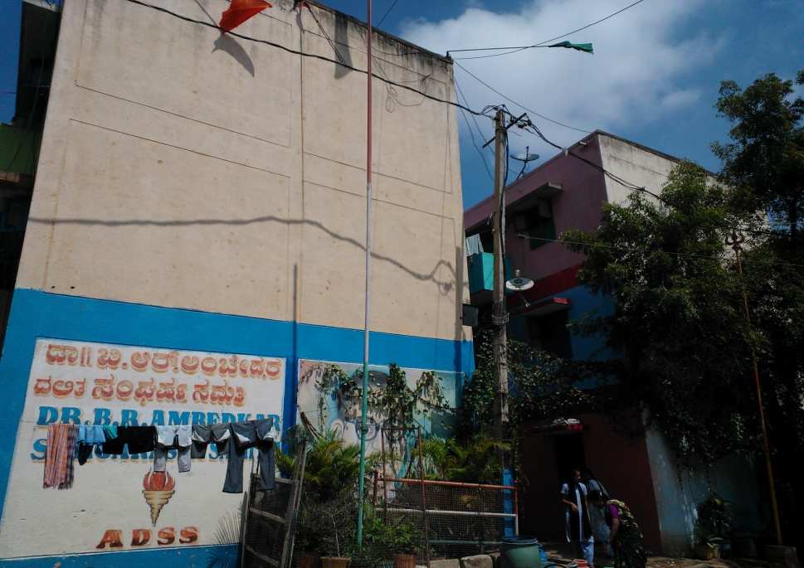 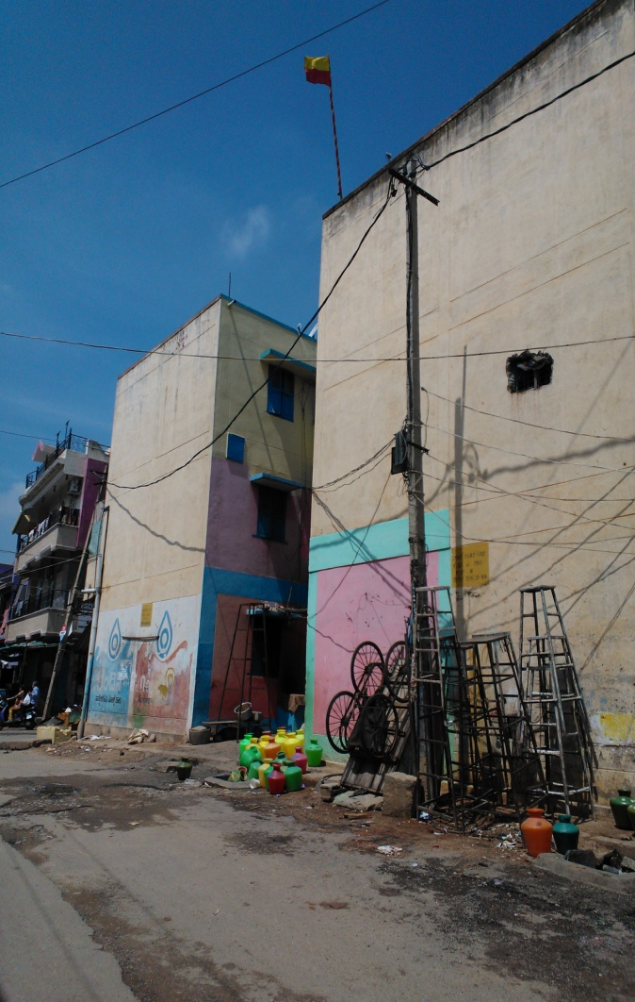

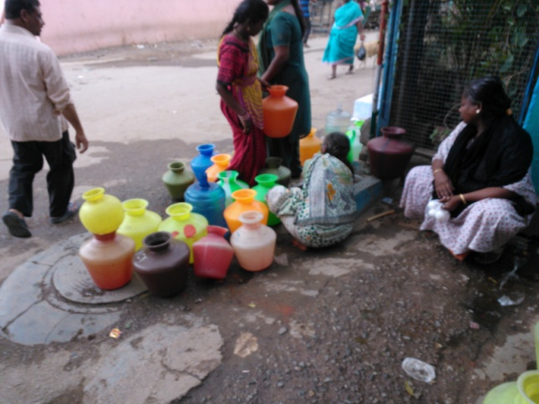 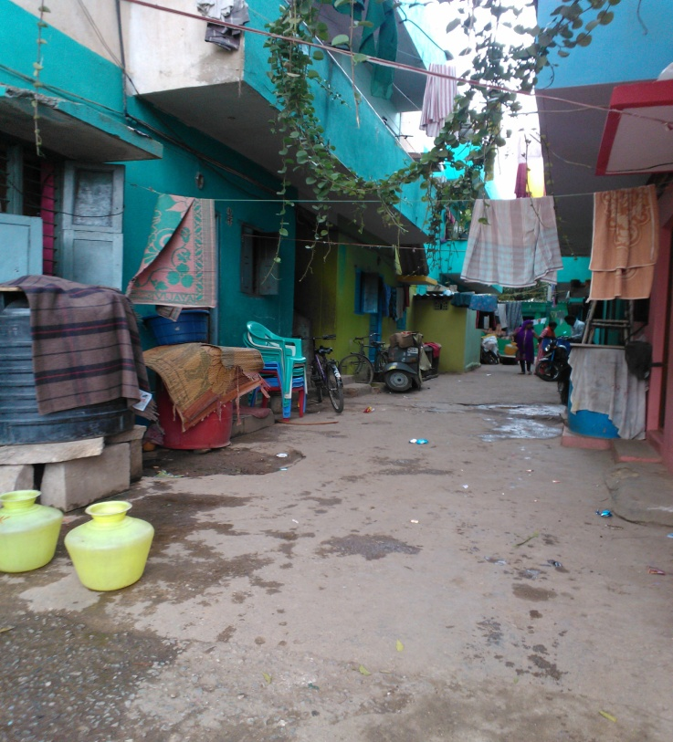

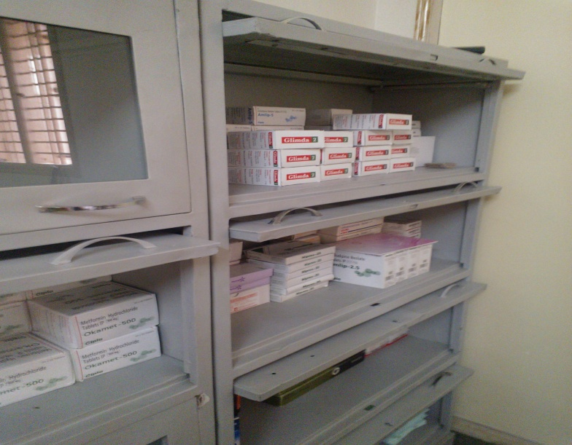

Generic medicines stock in the IPH Clinic

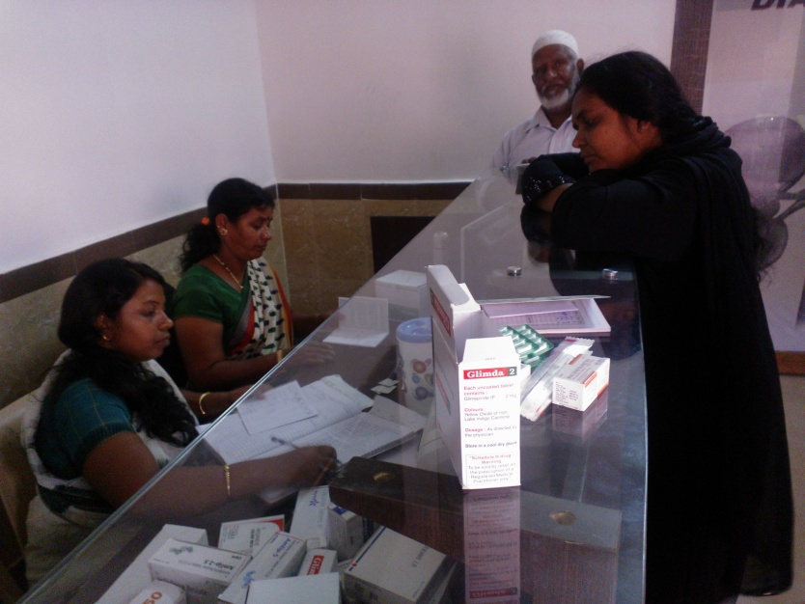

Dispensing generic medicines in the IPH clinic

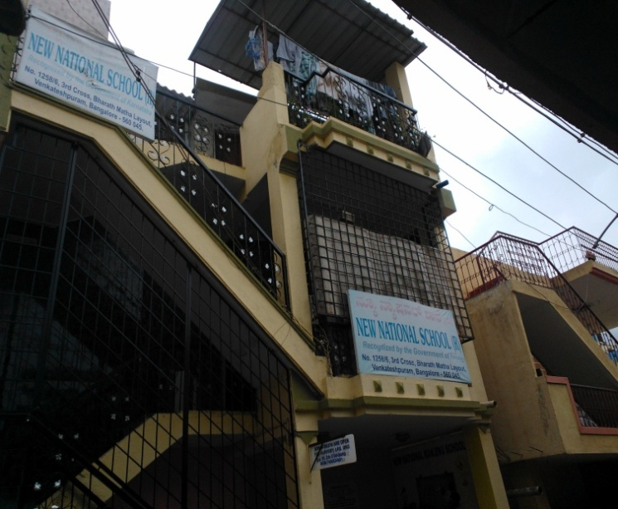

A private School in KG Halli

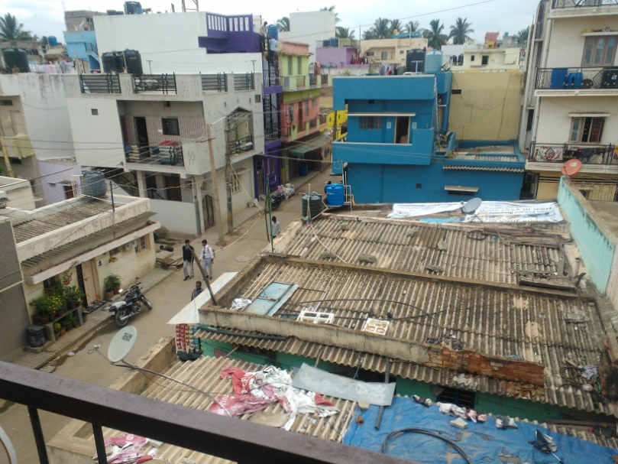

Aerial view of a neighbourhood in KG Halli

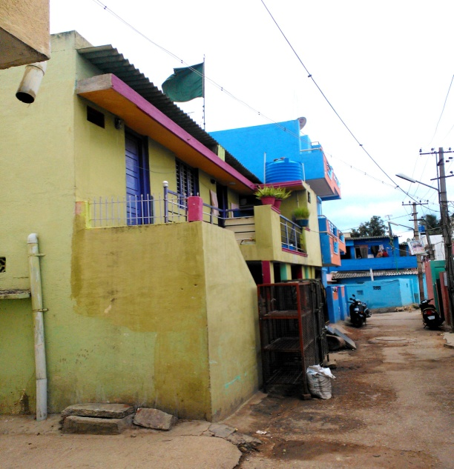

Street view of a neighbourhood in KG Halli

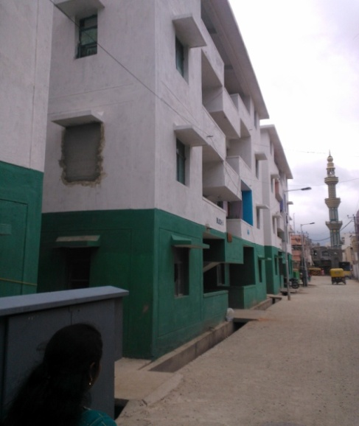

Corporation quarters: A former slum in KG Halli that was razed down and replaced by building quarters